Deploying real-time sensors to meet Summerfruit export requirements
Technical Report: Field testing the accuracy of
the Rubens Technologies handheld colourimeter
against the Minolta spectrophotometer

Agriculture Victoria Research
April/2021

Author: Dr Alessio Scalissi

Project RDC Number: FA042
Project CMI Number: 106243

Department of Jobs, Precincts and Regions
1 Spring Street Melbourne Victoria 3000
Telephone (03) 9651 9999
© Copyright State of Victoria,
Department of Jobs, Precincts and Regions
This publication may be of assistance to you but the State of Victoria and its employees do not guarantee that the publication is without flaw of any kind or is wholly appropriate for your particular purposes and therefore disclaims all liability for any error, loss or other consequence which may arise from you relying on any information in this publication. While every effort has been made to ensure the currency, accuracy or completeness of the content we endeavour to keep the content relevant and up to date and reserve the right to make changes as require. The Victorian Government, authors and presenters do not accept any liability to any person for the information (or the use of the information) which is provided or referred to in the report.

Unless indicated otherwise, this work is made available under the terms of the Creative Commons Attribution 3.0 Australia licence. To view a copy of this licence, visit creativecommons.org/licenses/by/3.0/au. It is a condition of this Creative Commons Attribution 3.0 Licence that you must give credit to the original author who is the State of Victoria.

Contents
EXECUTIVE SUMMARY 4
INTRODUCTION 5
Project outcome 6
Project background 6
Project objectives 7
METHOD 8
Determination of accuracy and precision of a portable colourimeter 8
Instrument description 8
Calibration of colour attributes 8
Validation of colour attributes 8
Data analysis 9
RESULTS 10
Accuracy and precision of a portable colourimeter 10
Calibration of colour attributes 10
Validation of colour attributes 10
CONCLUSION 12
RECOMMENDATIONS 12
REFERENCES 12
Acknowledgements 13

01.
Victorian Agriculture

EXECUTIVE SUMMARY
Fruit colour is a key quality parameter that is universally accepted across different markets and has been previously linked to fruit maturity in stone fruit. Skin colour can be affected by several genetic, management and environmental factors, with fruit exposure to light being one that commonly affects several crops and cultivars. In situ determinations of fruit colour are typically assessed by visual observations; however, these can be quite subjective and would be more accurately measured using a colourimeter. The objective of this work was to determine the accuracy and precision of a portable Bluetooth colourimeter for skin colour measurements in stone fruit. The study was conducted at the Tatura SmartFarm, Australia over summer 2021. The skin colour attributes measured with the colourimeter, namely L*, a* and b*, were calibrated against a reference spectrophotometer. C* and h° were obtained from a* and b*. Cross-validation models of colourimeter data versus data obtained with the reference spectrophotometer showed high precision and accuracy for the detection of L*, a* and b*.Overall, the device proved reliable and fast for skin colour detection in stone fruit.

INTRODUCTION
This technical report is a deliverable for the project FA042 Deploying real-time sensors to meet Summerfruit export requirements. The report details a study to determine accuracy and precision of a portable Bluetooth colourimeter to measure skin colour by comparing results with a reference spectrophotometer over a range of colour cards and stone fruits.
Fruit quality represents an important driver for future increases in value for exported Australian stone fruit. Stone fruit quality is not well defined, and it is strongly affected by the preferences of consumers, who generally demand red fruit with high sugar content. Fruit colour is one of the quality parameters that tends to be stable among markets. Consumers prefer red nectarines and peaches, and apricots with red blush, as they are commonly associated with flavour and sweetness and they suit celebrations of events such as Christmas or the Chinese New Year. The main skin components responsible for red colour formation in nectarines and peaches are anthocyanin pigments (Ravaglia et al. 2013). Growers need to guarantee consistent and optimal fruit colouration by applying best orchard and post-harvest practices. The most common orchard practices adopted to maximise fruit red colouration are the use of modern cultivars, summer and winter pruning to reduce tree vigour, crop load management, defoliation and the use of reflective mulch cloths to maximise fruit light interception, with the latter being less adopted in stone fruit compared to pome fruit. Water deficit has little to no direct influence on pigment formation in stone fruit but can reduce vegetative growth that in turn leads to increased red colouration (Gelly et al., 2003; O’Connell and Scalisi, 2021, accepted). Skin colour degradation may also be caused by storage disorders such as inking (Crisosto et al., 1999) or physical damage like bruises. Traditionally the skin background colour — the colour of the part of the fruit surface that is not covered by the red blush (Nunes, 2009) — proved to be a sensitive maturity indicator in peach (Crisosto, 1994). However, in modern plum, peach and nectarine cultivars with uniform skin colour, background colour is often not distinguished from the foreground colour, making it difficult to be used as a maturity index. Instead, Australian stone fruit growers prefer to use destructive measurements of soluble solids concentration and/or flesh firmness as the main parameters to assess maturity in situ.
Stone fruit growers typically track fruit colour development by visual assessments in the orchards and during the post-harvest supply chain. The adoption of objective measurements of colour using RGB cameras or spectrometers is less common. Handheld colourimeters such as the CM-2600d spectrophotometer (Konica Minolta, Tokyo, Japan) have been used to determine fruit colour development prior to harvest, but despite their high precision, they are not widely used due to the difficulty associated with extracting and interpreting the data and to their relatively high cost. Therefore, visual judgement based on previous knowledge and growers’ experience remains the most important tool to assess in situ fruit skin colour. However, growers working with modern peach and nectarine cultivars (i.e. fully coloured fruit) are less interested in measuring fruit colour as it does not represent a very accurate indicator of fruit quality.
In colour-measuring devices, reflectance spectra of the measured specimen are often used to determine colour in the CIELAB colour space (Greer et al., 2005). This three-dimensional space is characterised by quantitative colour attributes — namely L* (i.e. a lightness coefficient), a* [i.e. a scale of redness to greenness ranging from −60 (green) to +60 (red)] and b* [i.e. a scale of yellowness to blueness ranging from −60 (blue) to +60 (yellow)] (International Organisation for Standardisation, 1976). Hue angle (h°) and chroma (C*) are two further colour indices that can be calculated from L*, a* and b* (McGuire, 1992). The h° is calculated as the arc tangent of b*/a* and represents a 360° wheel where 0° (or 360°) is true red, 90° is true yellow, 180° is true green and 270° is true blue; C* represents colour vividness on a scale from 0 (diluted with white or darkened with black) to +60 (no colour dilution) and is calculated as the square root of a*² + b*² (Peavey et al., 2020). A three-dimensional colour space framework and the relative L*, a*, b*, C* and h° scales are summarised in Figure 1.
Byrne et al. (1991), Luchsinger and Walsh (1998) and Nunes (2008) observed that a* of skin background colour is related to maturity in nectarine and peach. Robertson et al. (1990) and Ferrer et al. (2005) highlighted relationships between skin h° and maturity in ‘Cresthaven’ and ‘Calanda’ peach cultivars, respectively. Both a* and h° are likely good indicators of maturity, with the latter being in theory the ideal parameter in fruit that possess a yellow intermediate step in the shift between green (immature) to orange-red (mature) or in fruit that simply go from green to yellow during ripening.
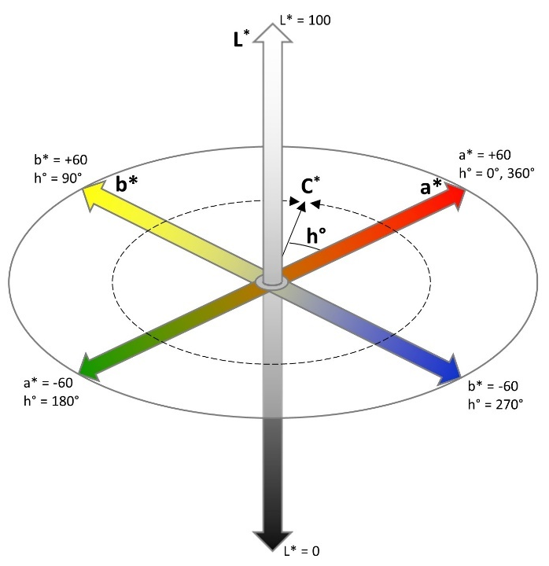
Figure 1. Schematic representation of L*, a*, b*, C* and h° in a three-dimensional colour space.
After harvest, RGB cameras and spectrometers can be the core technology of colourimeters used in laboratories or part of modern fruit sorting systems in packhouses that grade fruit into different classes based on quality characteristics. Recently, the use of ground-based mobile platforms to acquire tree-scale imagery to estimate tree size, flower cluster number and crop load has become popular in the apple and almond industry. This new technology offers the opportunity to measure fruit colour in situ. Overall, there is an increasing demand for cost-effective, user-friendly Ag-tech devices that can precisely assess fruit colour both in situ and post-harvest and that can be easily interfaced with smartphones for rapid data storage and display.

Project outcome
The identification of viable real-time sensors to assure quality on arrival in domestic and developing export markets and strengthened partnerships with industry and sensor technology partners.

Project background
Meeting export market specifications for quality is critical if expectations for price are to be met by Australian Summerfruit (peach, nectarine, apricot and plum) producers, packhouses and exporters. The pre- and post-harvest conditions under which these stone fruit crops are produced, harvested and handled have a marked effect on the quality and shelf life. Asian export supply chains are generally complex, have poor vertical integration, and lack the cool storage technology and systems needed to optimise quality and shelf life. Australian Summerfruit producers and exporters must therefore produce stone fruit that: satisfy consumer preference attributes for size, taste, colour and texture; meet export market access protocols for air and/or sea freight to China; and can survive short periods of sub optimal storage.
Emerging ‘Smart’ sensor technologies that continuously measure environmental conditions (e.g. temperature) and product quality (e.g. chlorophyll fluorescence) are tools that can be used to monitor pre- and post-harvest quality and power ‘models’ to predict appearance, eating quality and shelf life at destination markets. However, further development and demonstration of proof of concept sensors, predictive models and whole of chain information systems are needed to tangibly improve grower and export chain performance.
This project builds on previous exploratory work (Serviced Supply Chains project funded through Horticulture Innovation) to address stone fruit production and export chain performance issues (pain points) by testing and validating real-time sensor technologies that will assist growers and exporters to meet export requirements for China and other export markets.

Project objectives
- Develop, test and validate pre-harvest sensor technologies capable of cost-effectively collecting data that will inform orchard management and lead to improved prediction of harvest timing, fruit quality attributes, yield and grade.
- Develop, test and validate post-harvest sensor technologies capable of cost effectively collecting data that can inform or predict changing product quality and the development of storage disorders.

METHOD

Determination of accuracy and precision of a portable colourimeter

Instrument description
A portable Bluetooth colourimeter prototype (Rubens Technologies Pty Ltd, Figure 2) was tested for the measurement of L*, a* and b*. The colourimeter featured a D50 illuminant and separate red, green and blue (RGB) light intensity sensors as well as a total luminance sensor, all equipped with an IR light blocking filter. The light source was a white LED controlled via integrated logic. The colourimeter was connected to a smartphone via Bluetooth and logged data on the smartphone memory through a data logger app (“IDT data logger”) available for iOS devices. The app will be available on the Apple Store soon. RGB data were converted into CIELAB (i.e. L*, a* and b*) and CIELCH (i.e. L*, C* and h°) using a Python code (available at https://github.com/nevernervous78/rgb_to_Lab). The app allowed the collection of as many measurements per fruit as desired and safely stored data in the smartphone’s internal memory prior to data sharing. Data was then exported in a .csv file format. In addition, the smartphone application was able to read the labelling of near field communication (NFC) tags, which were coded with specific reference identifiers for scanned specimens (e.g. tree, fruit, treatment, replicate).

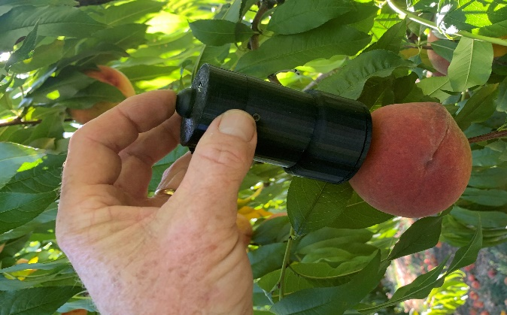
Figure 2. Portable Bluetooth colourimeter used for in situ measurement of L*, a* and b* and calculation of C* and h° in a ‘Redhaven’ peach fruit.

Calibration of colour attributes
The colourimeter was calibrated on 115 colour cards (calibration set) against a reference spectrophotometer (CM-2600d, Konica Minolta, Tokyo, Japan). RGB values were recorded and converted into XYZ and then into L*, a* and b* in a two-step process. One measurement per card was collected with each device. The calibration of the colourimeter’s L*, a* and b* against the reference spectrophotometer was carried out to correct the non-linearity of the colourimeter. The values of C* and h° were calculated from a* and b* as specified in the introduction.

Validation of colour attributes
Accuracy of the colourimeter was tested using a validation dataset composed by 160 scans on different reference surfaces, as detailed below:
• A calibration greyscale set (QPcard 102, QPcard) with four greyscale colours: dark grey (L* = 25, a* = 0 and b* = 0), medium grey (L* = 48, a* = 0 and b* = 0), light grey (L* = 80, a* = 0 and b* = 0) and white (L* = 95, a* = 0 and b* = 0). Five measurements were taken on each greyscale colour (n = 20).
• 20 ‘Angeleno’ plums (Prunus salicina L.).
• 20 ‘Golden May’ apricots (P. armeniaca L.).
• 20 ‘Snow Flame’ white peaches (P. persica L. Batsch).
• 20 ‘September Sun’ yellow peaches (P. persica L. Batsch).
• 20 ‘Rose Bright’ yellow nectarines (P. persica L. Batsch).
• 20 ‘Autumn Bright’ yellow nectarines (P. persica L. Batsch).
• 20 ‘Majestic Pearl’ white nectarines (P. persica L. Batsch).
Fruit of each cultivar had a good colour variability. Measurements were taken in a single spot that was marked with a circular area using a permanent marker. The same area was then scanned with the reference CM-2600d spectrophotometer.

Data analysis
Exploratory data analysis was conducted to identify patterns and any outliers in the calibration sets. The calibration models of colourimeter’s L*, a* and b* against the reference CM-2600d spectrophotometer’s L*, a* and b* were obtained with regression analysis. The calibration models were applied to the colourimeter output and the prediction of L*, a* and b* in the validation dataset was compared to the observed L*, a*, b* obtained with the reference CM-2600d spectrophotometer. Lin’s concordance correlation coefficient (rc) (Lin, 1989) was used to determine accuracy of the relationship of colourimeter’s L*, a* and b* against the CM-2600d spectrophotometer’s L*, a* and b* after validation. Data was analysed with JASP v. 0.14. 1 (Jasp Team 2018, Computer software) and plotted using SigmaPlot 12.5 (Systat Software, San Jose, CA).

RESULTS

Accuracy and precision of a portable colourimeter

Calibration of colour attributes
The uncalibrated colourimeter’s L*, a* and b* were related to the reference L*, a* and b* — i.e. obtained with the spectrophotometer — by quadratic relationships, as suggested by scatterplots in Figure 3. The quadratic models had R2 > 0.9 (Table 1) and were used to calibrate the L*, a* and b* measurements obtained with the colourimeter from the uncalibrated readings (i.e. L*u, a*u and b*u). The calibration algorithms were loaded onto the colourimeter’s firmware so that the output data was pre-processed with the correction.

Validation of colour attributes
Predicted values of L*, a* and b* in the validation samples were very similar to the reference spectrophotometer’s values (Figure 4). In fact, a rc > 0.90 was observed when testing precision and accuracy of L*, a* and b* prediction (Table 2), meaning that the predicted data aligned satisfactorily with reference observations. A little curvature of the relationship persisted in the low portion of L* data (L* < 40) since the calibration was done with a sample that lacked L* values in the 20 – 40 range. However, the RMSE suggested that the prediction accuracy error remained relatively low even for L* (Table 2). This confirmed the suitability of the portable Bluetooth colourimeter for rapid skin colour assessments in peaches, plums, nectarines and apricots.
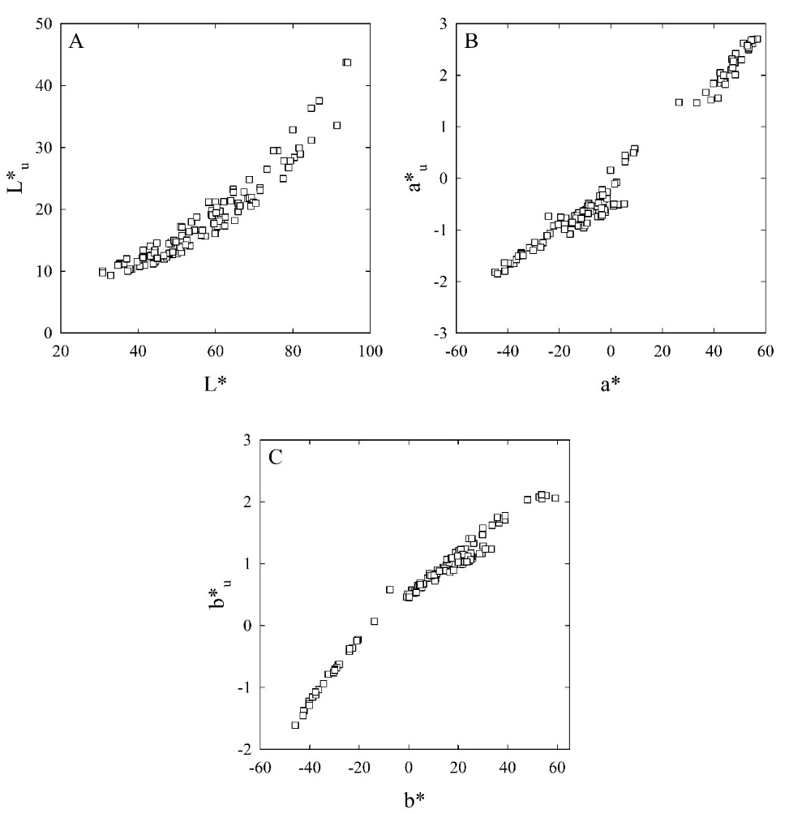
Figure 3. Scatter plots of uncalibrated colourimeter’s L* (L*u, A), a* (a*u, B) and b* (b*u, C) against reference spectrophotometer’s L*, a and b* done on 115 colour cards (calibration set).

Table 1. Quadratic equations used to calibrate the uncalibrated colourimeter’s L* (L*u), a* (a*u) and b* (b*u) against reference spectrophotometer’s L*, a* and b*. Coefficient of determination (R2), significance level (p) and sample size reported.
Colour parameter | Equation | R² | p | n
L* | L* = − (0.04 L*_{u}²) + (3.91 L*_{u}) + 1.58 | 0.947 | <0.001 | 115
a* | a* = − (1.87 a*_{u}²) + (22.91 a*_{u}) + 5.87 | 0.976 | <0.001 | 115
b* | b* = (2.69 b*_{u}²) + (26.14 b*_{u}) − 12.03 | 0.975 | <0.001 | 115

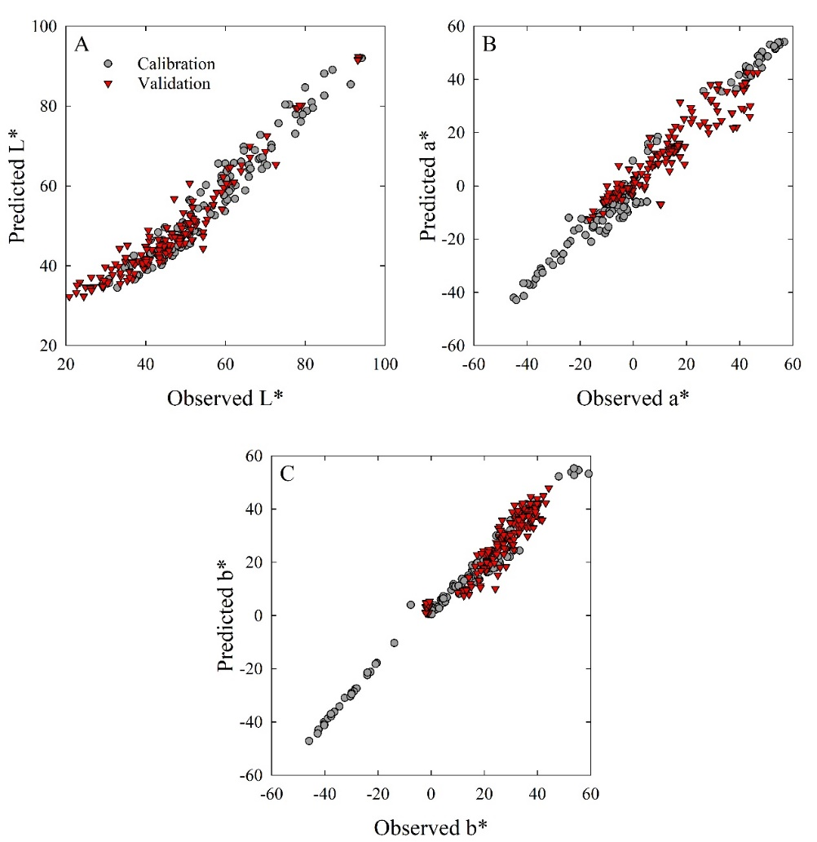
Figure 4. Scatter plots of validation datasets of colourimeter’s L* (A), a* (B) and b* (C) (predicted) against reference spectrophotometer’s L*, a* and b* (observed), respectively.
Table 2. Lin’s concordance correlation coefficient (rc) with 95% confidence intervals (in brackets) and root mean square error (RMSE) reported for the validation models obtained with colourimeter’s L*, a* and b* (predicted variables) against spectrophotometer’s L*, a* and b* (observed variables).
Colour parameters | n | r_{c} | RMSE
L* | 160 | 0.930 (0.040) | 5.158
a* | 160 | 0.924 (0.043) | 5.747
b* | 160 | 0.946 (0.033) | 4.373

CONCLUSION
The handheld Bluetooth colourimeter used in this study proved accurate and precise for the detection of L*, a* and b* in stone fruit, as demonstrated by the cross-validation results shown in Figure 4 and Table 2 on a comprehensive dataset that included different stone fruit crops. The instrument allowed very rapid measurements and can be used for data collection in situ or post-harvest as it is interfaced via Bluetooth connectivity with a smartphone application that serves as data logger and stores data in the internal memory. The use of an external data logging device such as a smartphone or a tablet contributes to the reduction of the instrument’s size and weight, making it a portable tool that can be easily carried to the measurement site (i.e. orchard, packhouse, cool store, distribution centre).

RECOMMENDATIONS
The adoption of quantitative colour parameters such as L*, a*, b*, C* and h° for fruit quality and maturity determination helps overcome an often obsolete, qualitative and subjective classification into visual colour categories and opens the door to powerful machine learning algorithms that can quickly monitor fruit colour changes over time and on the go. For example, algorithms for the detection of L*, a*, b* C* and h° have a great potential for precision agriculture applications involving Ag-technologies such as robots, drones and mobile platforms for automation of common practices like fruit maturity estimation or robotic harvesting. However, this concept is only valid for fruit crops and cultivars that show a clear pattern of colour change when approaching maturity.

REFERENCES
Byrne, D. H., Nikolic, A. N., & Burns, E. E. (1991). Variability in sugars, acids, firmness, and color characteristics of 12 peach genotypes. Journal of the American Society for Horticultural Science, 116(6), 1004-1006. https://doi.org/10.21273/JASHS.116.6.1004
Crisosto, C. H. (1994). Stone fruit maturity indices: a descriptive review. Postharvest News and Information, 5(6), 65N-68N.
Crisosto, C. H., Johnson, R. S., Day, K. R., Beede, B., & Andris, H. (1999). Contaminants and injury induce inking on peaches and nectarines. Plant Health Progress, 1(1), 7. https://doi.org/10.3733/ca.v053n01p19
Ferrer, Ana, Sara Remón, Angel I. Negueruela, and Rosa Oria. "Changes during the ripening of the very late season Spanish peach cultivar Calanda: feasibility of using CIELAB coordinates as maturity indices." Scientia Horticulturae 105, no. 4 (2005): 435-446. https://doi.org/10.1016/j.scienta.2005.02.002
Gelly, M., Recasens, I., Mata, M., Arbones, A., Rufat, J., Girona, J., & Marsal, J. (2003). Effects of water deficit during stage II of peach fruit development and postharvest on fruit quality and ethylene production. The Journal of Horticultural Science and Biotechnology, 78(3), 324-330. https://doi.org/10.1080/14620316.2003.11511626
Greer, D. H. (2005). Non‐destructive chlorophyll fluorescence and colour measurements of ‘Braeburn’ and ‘Royal Gala’ apple (Malus domestica) fruit development throughout the growing season. New Zealand Journal of Crop and Horticultural Science, 33(4), 413-421. https://doi.org/10.1080/01140671.2005.9514378
International Organisation for Standardisation, (1976). CIE 1976 L*a*b* Colour Space. (ISO/CIE 11664-4:2019). Geneva, Switzerland
Luchsinger, L.E. and Walsh, C.S. (1998). Development of an objective and non-destructive harvest maturity index for peaches and nectarines. Acta Hortic. 465, 679-688. https://doi.org/10.17660/ActaHortic.1998.465.85
McGuire, R. G. (1992). Reporting of objective color measurements. HortScience, 27(12), 1254-1255. https://doi.org/10.21273/hortsci.27.12.1254
Nunes, M.C.d.N. (2009). Pome and Stone Fruits. In Color Atlas of Postharvest Quality of Fruits and Vegetables, M.C.d.N. Nunes (Ed.). https://doi.org/10.1002/9780813802947
O’Connell M.G., and Scalisi, A. (2021). Sensing fruit and tree performance under deficit irrigation in ‘September Bright’ nectarine. Accepted by Acta Horticulturae.
Peavey, M., Goodwin, I., McClymont, L., & Chandra, S. (2020). Effect of Shading on Red Colour and Fruit Quality in Blush Pears “ANP-0118” and “ANP-0131”. Plants, 9(2), 206. https://doi.org/10.3390/plants9020206
Ravaglia, D., Espley, R. V., Henry-Kirk, R. A., Andreotti, C., Ziosi, V., Hellens, R. P., ... & Allan, A. C. (2013). Transcriptional regulation of flavonoid biosynthesis in nectarine (Prunus persica) by a set of R2R3 MYB transcription factors. BMC plant biology, 13(1), 68. https://doi.org/10.1186/1471-2229-13-68
Robertson, J. A., Meredith, F. I., Horvat, R. J., & Senter, S. D. (1990). Effect of cold storage and maturity on the physical and chemical characteristics and volatile constituents of peaches (cv. Cresthaven). Journal of Agricultural and Food Chemistry, 38(3), 620-624. https://doi.org/10.1021/jf00093a008

Acknowledgements
This study was a component of the project "Deploying real-time sensors to meet Summerfruit export requirements" a joint venture between Agriculture Victoria, the Summerfruit Industry, RMIT University and two Ag Tech companies — Green Atlas and Rubens Technologies Pty Ltd. The project was financially supported by the Food Agility CRC through the Australian Commonwealth Government CRC Program with co-investment from Agriculture Victoria, Summerfruit Australia Limited and RMIT University.

