Deploying real-time sensors to meet Summerfruit export requirements
Technical report: Calibration of a handheld fluorescence-reflectance sensor to measure fruit quality attributes in stone fruit
Agriculture Victoria Research
July 2021

Authors: Mark O’Connell, Alessio Scalisi, Daniel Pelliccia, Christine Frisina, Ian Goodwin

Food Agility CRC Project Number: FA042
Project CMI Number: 106243

Department of Jobs, Precincts and Regions
1 Spring Street Melbourne Victoria 3000
Telephone (03) 9651 9999
© Copyright State of Victoria,
Department of Jobs, Precincts and Regions
This publication may be of assistance to you but the State of Victoria and its employees do not guarantee that the publication is without flaw of any kind or is wholly appropriate for your particular purposes and therefore disclaims all liability for any error, loss or other consequence which may arise from you relying on any information in this publication. While every effort has been made to ensure the currency, accuracy or completeness of the content we endeavour to keep the content relevant and up to date and reserve the right to make changes as require. The Victorian Government, authors and presenters do not accept any liability to any person for the information (or the use of the information) which is provided or referred to in the report.

Unless indicated otherwise, this work is made available under the terms of the Creative Commons Attribution 3.0 Australia licence. To view a copy of this licence, visit creativecommons.org/licenses/by/3.0/au. It is a condition of this Creative Commons Attribution 3.0 Licence that you must give credit to the original author who is the State of Victoria.
Contents
EXECUTIVE SUMMARY 4
INTRODUCTION 5
Project outcome 5
Project background 5
Project objectives 5
METHOD 6
Calibration of a handheld fluorescence-reflectance sensor 6
Instrument description 6
Calibration of fruit quality 7
RESULTS 10
Laboratory calibration of the fluorescence-reflectance sensor 10
Field calibration of the handheld fluorescence-reflectance sensor 13
DISCUSSION 15
CONCLUSION 15
RECOMMENDATIONS 15
REFERENCES 16
Acknowledgements 16
Appendices 16

01.
Victorian Agriculture

EXECUTIVE SUMMARY
Fruit quality, particularly fruit maturity, is a key element for orchard profitability and high consumer acceptance in domestic and export markets for stone fruit. Stone fruit growers undertake destructive measurements of fruit quality on a small sample size at pre- and post-harvest. Industry metrics currently used to assess fruit quality include aroma, fruit size, skin and flesh colour, flesh firmness (FF) and soluble solids concentration (SSC). The objective of this study was to calibrate a handheld, non-destructive Bluetooth fluorescence-reflectance spectrometer against fruit quality measurements in stone fruit. The study was conducted at the Tatura SmartFarm, Australia over summer 2020/21. Laboratory calibration was undertaken on three cultivars for fruit ethylene emission, index of absorbance difference (I_{AD}), FF and SSC. Subsequent field testing was undertaken on one cultivar for fruit FF and SSC. Partial least squares (PLS) regression combined with cross-validation models of spectra and fruit quality data showed high accuracy for estimates of ethylene emission, FF and SSC. Overall, the sensor proved robust, reliable and fast for fruit quality measurements in stone fruit.

INTRODUCTION
This technical report is a deliverable for the project FA042 Deploying real-time sensors to meet Summerfruit export requirements. The report details a study to calibrate a portable Bluetooth fluorescence-reflectance sensor against existing reference measures of fruit quality.

Project outcome
The identification of viable real-time sensors to assure quality on arrival in domestic and developing export markets and strengthened partnerships with industry and sensor technology partners.

Project background
Australian Summerfruit growers and exporters must produce high yields of fruit that satisfy consumer preference attributes for size, taste, aroma, colour and texture. Export markets are very competitive, and Australia must be able to guarantee a quality product. However, fruit is a perishable product and Summerfruit (peach, nectarine, apricot and plum) are particularly vulnerable to deterioration in quality during storage, transport and handling.
How fruit is grown and the environmental condition during the growing season will substantially influence yield and fruit quality attributes. For example, management inputs such as thinning, irrigation and tree training can be used to manipulate fruit size, soluble solids concentration (i.e. sweetness), colour and how quickly fruit matures (i.e. ripeness). Fruit maturity determines when to pick the fruit and ideally this can be measured by ethylene emitted by fruit. Picking at the correct fruit maturity is critical for storage, transport and handling so that the end product matches consumer preferences. Currently, some growers use a DA meter (calibrated to cultivar-specific ethylene emission) to estimate maturity; however, most growers are largely informed by subjective observations of size, flesh firmness and taste.
Emerging ‘Smart’ sensor technologies that estimate in situ yield and product quality (e.g. size, colour, soluble solids concentration, flesh firmness and ethylene) are tools that can be used to make informed decisions on orchard management inputs, harvest timing, storage, shelf life and destination markets. However, further development and demonstration of proof of concept sensors are needed to tangibly improve grower and export chain performance.
This project builds on previous work on estimating pre-harvest yield and measures of fruit quality using technologies such as optical imagery, LiDAR, fluorescence and reflectance spectroscopy combined with image analysis and machine learning. The project will test the accuracy and assess the utility of real-time sensor technologies and easy to use dashboards that will assist growers and exporters to meet export requirements.

Project objectives
- Develop, test and evaluate pre-harvest sensor technologies capable of cost-effectively collecting data that will inform orchard management and lead to improved prediction of harvest timing, fruit quality attributes, yield and grade.
- Develop, test and evaluate post-harvest sensor technologies capable of cost effectively collecting data that can inform or predict changing product quality and the development of storage disorders.

METHOD

Calibration of a handheld fluorescence-reflectance sensor

Instrument description
The prototype fluorescence-reflectance spectrometer (Rubens Technologies Pty Ltd) was calibrated for the measurement of SSC, FF and ethylene emission. The sensor features a visible light spectrometer, with sensitivity in the wavelength range 350 – 950 nm, and three independent LED light sources: near infrared (broadband emission in the range of approximately 650 – 1050 nm), white light (broadband emission in the range 400 – 700 nm) and ultra-violet (UV) with near-monochromatic emission at 365 nm. The fluorescence of chlorophyll and other pigments in the fruit skin occurs upon excitation with UV light, while the two other illumination models provide diffuse reflectance information in the visible – near infrared bands. The data is background-corrected and stored for further analysis.
The spectrometer can be connected to a smart phone via Bluetooth and records data through a proprietary app (Figure 1). Alternatively, it can be connected to a computer and readout via USB cable or via Bluetooth (Figure 2). In both cases, the saved raw data is made of background-corrected spectra and wavelength information.
The spectrometer features a measurement cup which prevents background light reaching the sensor during measurements thus enabling in-field use. The gap between the spectrometer sensor and the surface of the fruit was kept constant at a value of 10 mm. The measured spectra were normalised to the total emission prior to data analysis.

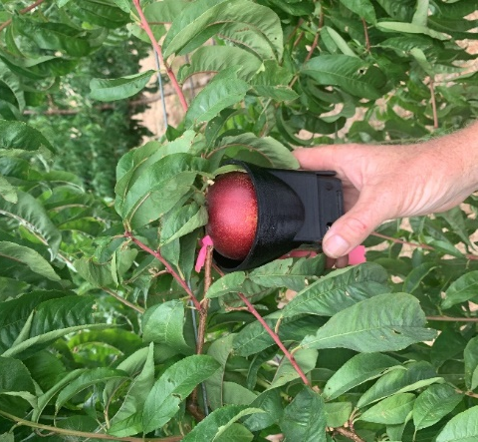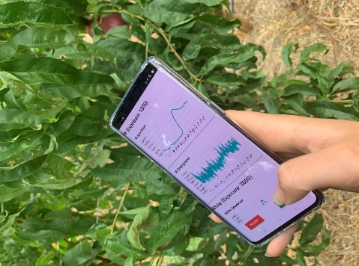
Figure 1. The fluorescence-reflectance spectrometer (Rubens Technologies Pty Ltd) and smartphone APP software display showing spectra response for the measurement of fruit quality of nectarine ‘Majestic Pearl’ at Tatura SmartFarm.

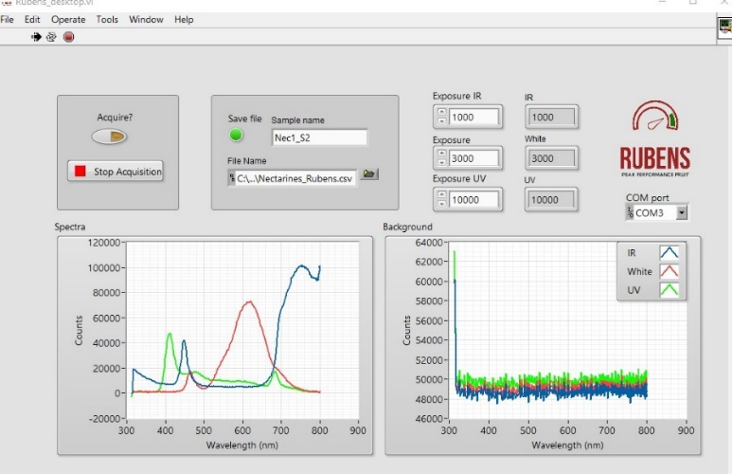
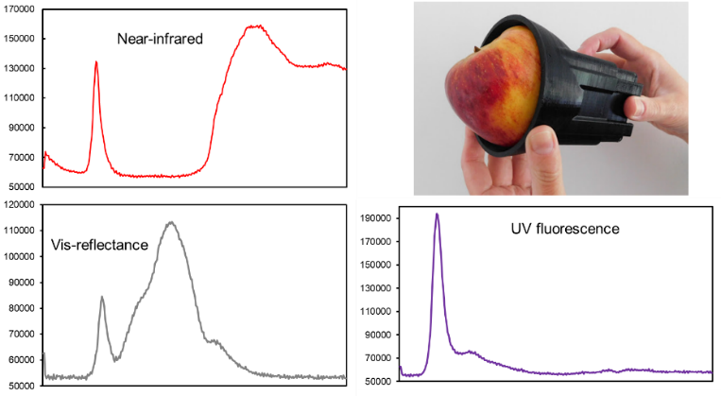
Figure 2. Example spectra responses (near-infrared, vis-reflectance, UV fluorescence) of the fluorescence-reflectance spectrometer (Rubens Technologies Pty Ltd) on computer software display for the measurement of fruit quality of peach and nectarine at Tatura SmartFarm.

Calibration of fruit quality

Study site and cultivars
The experiment was conducted at the Tatura SmartFarm (36°26'7'' S and 145°16'8'' E, 113 m a.s.l.) in the Goulburn Valley, Victoria, Australia. Fruit was sourced from the stone fruit experimental orchard and the Sundial orchard at the SmartFarm. Further details of experimental orchards can be found online: http://www.hin.com.au/networks/profitable-stonefruit-research/stonefruit-research-orchard-and-equipment/summary-of-field-experiments-and-demonstration-blocks.
To calibrate the prototype fluorescence-reflectance spectrometer for field and export chain measures of stone fruit quality, four cultivars covering a range of commercial harvest dates (early-, mid- and late-season), fruit sweetness (low to high) and maturity (low to high) were assessed during season 2020/21:
- White flesh peach (Prunus persica L. Batsch, ‘Snow Flame 25’) harvested mid-December 2020.
(ii) White flesh nectarine (P. persica L. Batsch, ‘Majestic Pearl’) harvested mid-January 2021.
(iii) Yellow flesh peach (P. persica L. Batsch, ‘O’Henry’) harvested early-February 2021.
(iv) Yellow flesh peach (P. persica L. Batsch, ‘September Sun’) harvested early-March 2021.

Laboratory calibration of the fluorescence-reflectance sensor
Calibration of the fluorescence-reflectance sensor against fruit quality attributes was undertaken on ‘Snow Flame 25’ peach, ‘Majestic Pearl’ nectarine and ‘O’Henry’ peach under laboratory conditions. A minimum of 100 fruit per cultivar were randomly hand-picked at three physiological maturity classes defined by ethylene production that was estimated from index of absorbance difference (I_{AD}) measurements with a DA meter (model 53500, T.R. Turoni, Forli, Italy). Fruit maturity classes were:
(i) No ethylene – no ethylene production by the fruit.
(ii) Onset – consistent production of very small concentrations of ethylene.
(iii) Climacteric – high level of ethylene production.
To derive calibration relationships, destructive and non-destructive measures on the same fruit were conducted to compare SSC, FF, I_{AD} and ethylene emission (Table 1) with fluorescence-reflectance spectra. Firstly, fruit were individually and uniquely identified (numbered), non-destructively scanned using the fluorescence-reflectance spectrometer and DA meter and then placed into glass chambers to obtain an ethylene sample. After obtaining an ethylene sample, fruit was removed from the chamber and destructive measures were conducted to obtain flesh SSC and FF.
Ethylene production was determined using the static measurement method. The fresh weight of individual fruit was measured. Subsequently, fruit were placed into gas tight glass chambers of known volume (350 and 500 mL) and left at ambient temperature for up to 3 h. Samples were collected according to Frisina et al. (2018) and held at room temperature until analysis. Samples were injected into a gas chromatograph (Varian 3800, Agilent Technologies, USA) fitted with a flame ionisation detector and GSQ Agilent – 115-3432 GS-Q capillary column (30 m x 0.530 mm 0.0 µ, −60 to 250 °C; Agilent technologies, USA) and set at an oven temperature of 30 °C, a detector temperature of 260 °C and a flow rate of 30 mL per min N₂. Results were compared to a known standard gas mix with a concentration of 2.11 µL ethylene per L N₂ (Coregas Ltd, Yennora NSW, Australia).

Table 1. Fruit quality attributes measured.
Quality Attribute | Equipment | Units
Index of absorbance difference (I_{AD}) | DA meter | Unitless
Ethylene production rate | Gas chromatograph | µL per kg fruit fresh weight per h
Flesh firmness | Penetrometer | kg force
Soluble solids concentration | Refractometer | ºBrix

Fruit fluorescence-reflectance sensor spectra and laboratory non-destructive I_{AD} and destructive SSC and FF measurements were collected on a cheek of each individual fruit along the equatorial diameter, avoiding fruit sutures (Fig. 3).
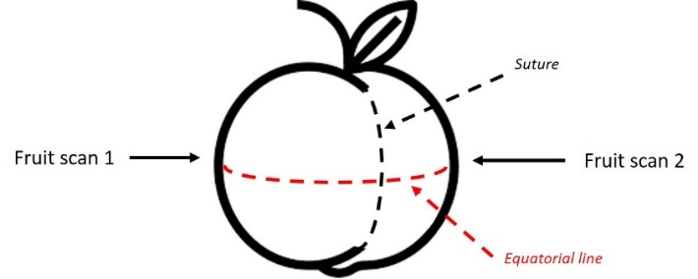
Figure 3. Position of fluorescence-reflectance sensor and fruit quality measurements along the equatorial diameter.

Fruit skin was peeled off from the area previously scanned with the non-destructive sensors (DA meter, fluorescence-reflectance sensor), and flesh exposed to a penetrometer (FT327, FACCHINI srl, Alfonsine, Italy) equipped with an 8 mm tip to measure FF on a scale from 0 to 15 kgf. Subsequently, a few drops of flesh juice were extracted, and SSC measured using a digital refractometer (PR-1; Atago Co. Ltd., Saitama, Japan) and expressed as °Brix.

Field calibration of the fluorescence-reflectance sensor
‘September Sun’ peach was used for field calibration using the same method as the other three cultivars calibrated under laboratory conditions. Field (i.e. in situ) fruit quality fluorescence-reflectance sensor measurements were collected two weeks and one week before harvest and at harvest. At each sampling interval, approximately 40 representative fruits were randomly selected, measured using the fluorescence-reflectance sensor, labelled and transported to the laboratory. Destructive measures of SSC and FF (Table 1) were compared to the fluorescence-reflectance sensor spectra obtained in the field. Measurements were collected on a cheek of each fruit (Fig. 3). No ethylene validation data were collected due to large fruit diameter of ‘September Sun’ peach fruit exceeding the glass chamber capacity for static measurement.

Prediction modelling of fruit quality attributes
To achieve fruit quality prediction, this work focused on analysing the measured spectra using a machine learning approach. Prediction models for ethylene emission, FF, SSC and I_{AD} were carried out using partial least square (PLS) regression with spectral band optimisation. In the case of ethylene, we used the natural logarithm of fruit emission (uL/kg.hr) to improve prediction power. All models were optimised using a k-fold cross-validation procedure using k = 10 splits. The basic idea was to select the most informative wavelength bands out of the entire spectral response. The selection was done via a random optimisation procedure called simulated annealing (SA) (van Laarhoven and Aarts 1987). This algorithm begins with a randomly selected set of bands and, at each iteration, randomly changes a subset of these bands. A PLS regression model was developed at each iteration and the Akaike information criterion (AIC) (Akaike 1974) was used as the cost function. The aim of the algorithm was to decrease the cost functions, hence, to improve the model. The coefficients of determination for the cross-validation procedure (R²_{CV}) and Lin’s concordance correlation coefficients (r_{c}) (Lin 1989) were calculated to assess models’ robustness, with the latter being a reliable measure of the agreement between two variables. The r_{c} is particularly useful when comparing two measures of the same variable, such as when x (observed values) and y (predicted values) are in the same unit. The best models had the highest agreement between x and y and generated a r_{c} closer to 1 in a 0 – 1 range. The root mean square error in cross-validation (RMSE_{CV}) was also calculated to provide a measure of error in the same unit of the measured variable.
The SA optimisation procedure is a variant of a greedy optimisation strategy whereby the algorithm seeks to decrease the cost function, but not monotonically. SA allows for the occasional increase of the cost function to reduce the likelihood of the process getting stuck in a local minimum of the parameter space. In order for the SA process to be effective, the increase of the cost function must be occasional; in other words, it must happen with a small probability, governed by a hyper-parameter, which we chose to be equal to 0.1% of the current value of the AIC at each iteration.
The algorithm workflow was as follows:
1. Individual spectral channels (i.e. NIR reflectance, vis-reflectance and UV fluorescence) were smoothed using Savitzky–Golay filter with 11-points window and polynomial order of 2.
2. Spectra were “re-binned” into 72 wavelength bands obtained by adding 4 contiguous wavelength bins.
3. The resulting spectra, still within their individual channels, were then mean-centered and scaled to unit variance.
4. After these pre-processing steps the spectra were concatenated together (thus obtaining 216 data point per spectrum) and subsequently fed in the SA algorithm. In some cases, we found that the vis-reflectance spectra did not appreciably contribute to the model quality and therefore only NIR-reflectance and UV fluorescence spectra were concatenated. The algorithm starts with a random draw of 50 bands (out of the total 216). At each iteration, a subset of two bands were randomly swapped, a PLS model was developed and cross-validated on the collection of bands selected by the SA. The optimum PLS model at each step was obtained by minimising the AIC. The algorithm was run for 5000 iterations.
The number of selected bands (50 in our case) was fixed for all models and initially chosen in accordance with the empirical optimal value of the latent variables selected by the cross-validation process. The choice was done by running SA optimisations with increasing numbers of bands multiple times and evaluate the metrics. R²_{CV}, r_{c}, RMSE_{CV}, AIC and number of latent variables (LV) in the models were presented for the preferred PLS models.
The algorithms were implemented in PythonTM 3.7.6 using the PLS regression and LDA routines available in the Scikit-learn package (v. 0.22.2) (Pedregosa et al. 2011). Sample scripts of the algorithms are freely available as a Project Jupyter Notebook (Pelliccia 2021).

RESULTS

Laboratory calibration of the fluorescence-reflectance sensor
Figures 4 – 6 shows predicted plotted against observed fruit FF, SSC, ethylene and I_{AD} for the three cultivars used in this study. PLS statistics are reported in Table 2.
Overall, a visual assessment of the concordance between the two variables suggested that the PLS models provided a good estimation of the fruit quality attributes FF, SSC, ethylene and I_{AD}, as model linear fits were relatively close to a y = x reference line (Figures 4 – 6). Using ethylene as an example, linear fits show that the PLS models in the three cultivars slightly overestimated ethylene when its values were low (i.e. immature fruit) and underestimated them when they were high (i.e. mature fruit). The model’s linear fit for Peach ‘Snow Flame 25’ fruit was the closest to the y = x line and had the highest r_{c} (0.93, Table 2).

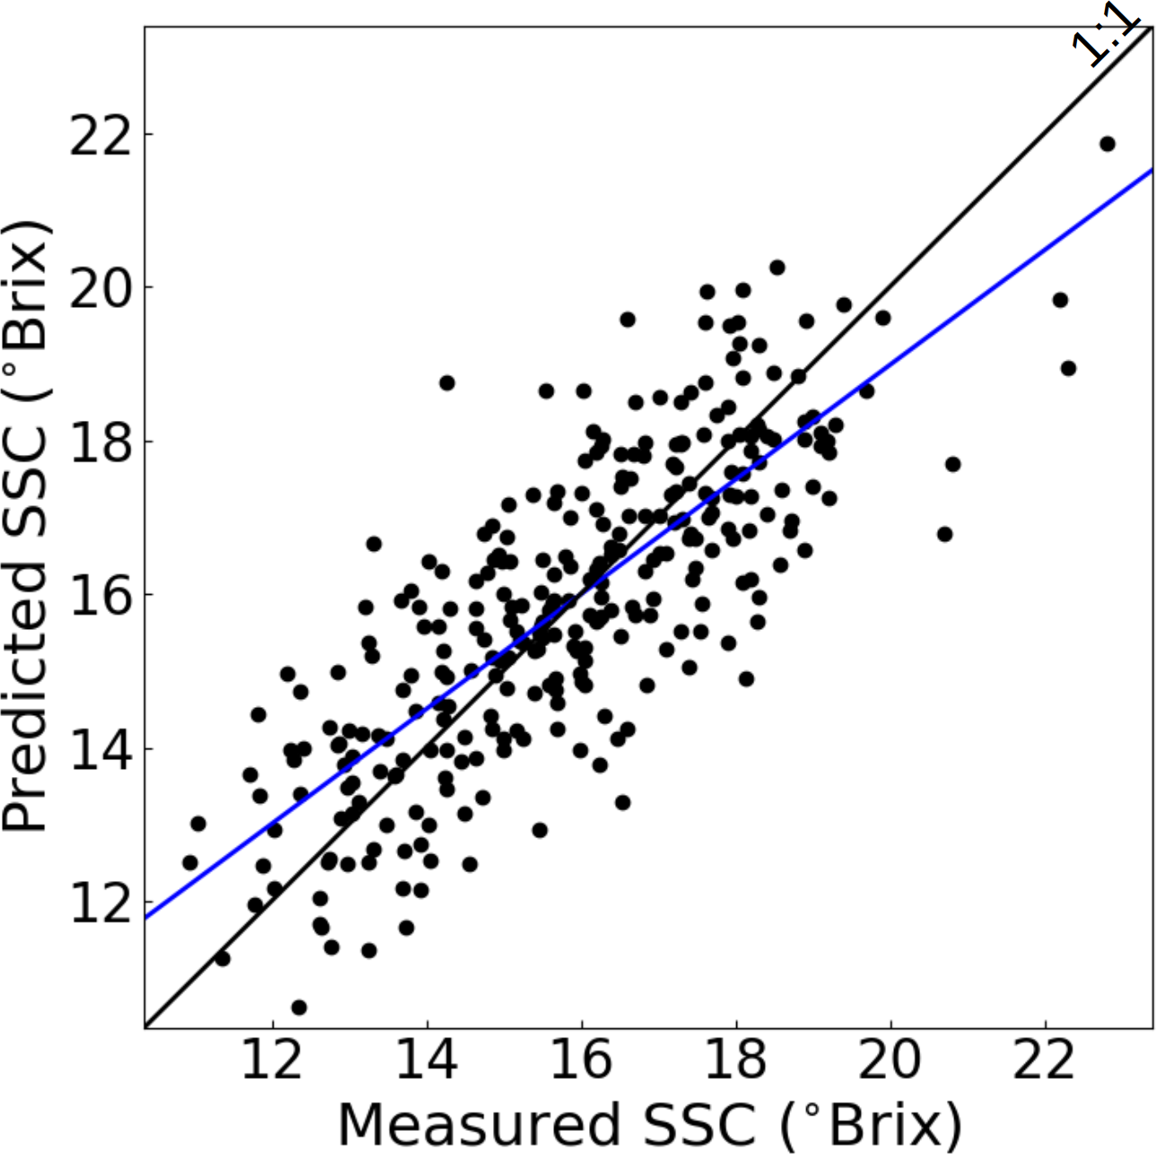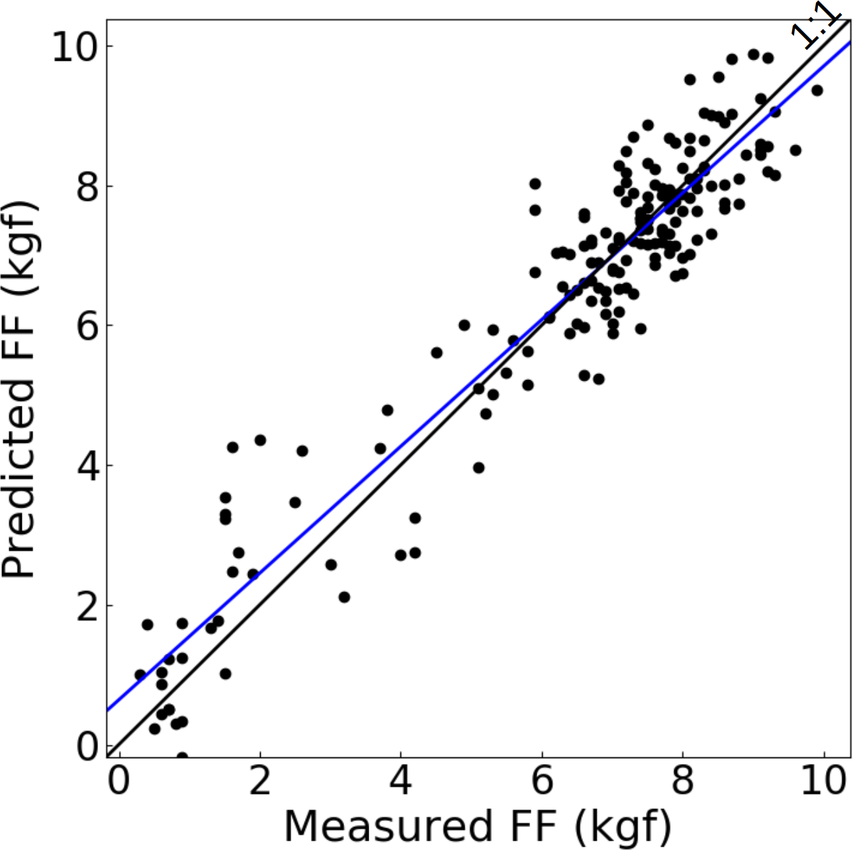
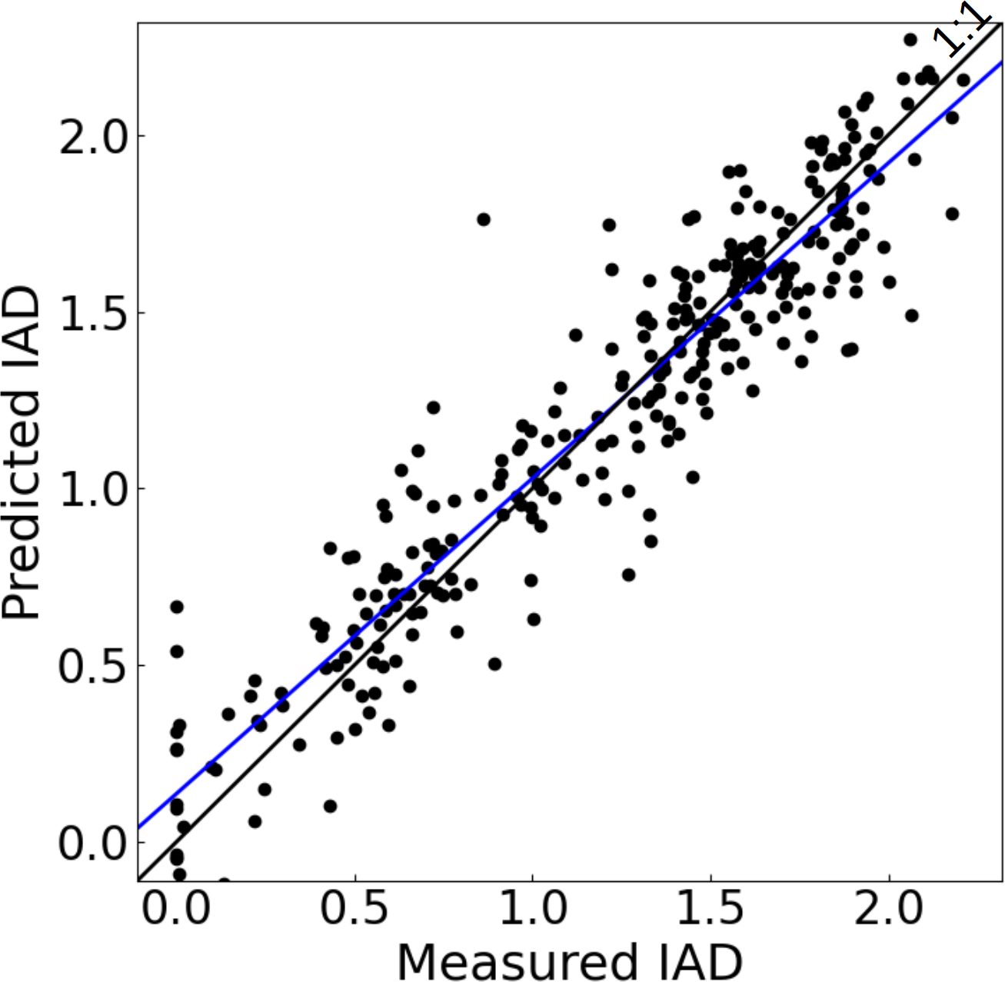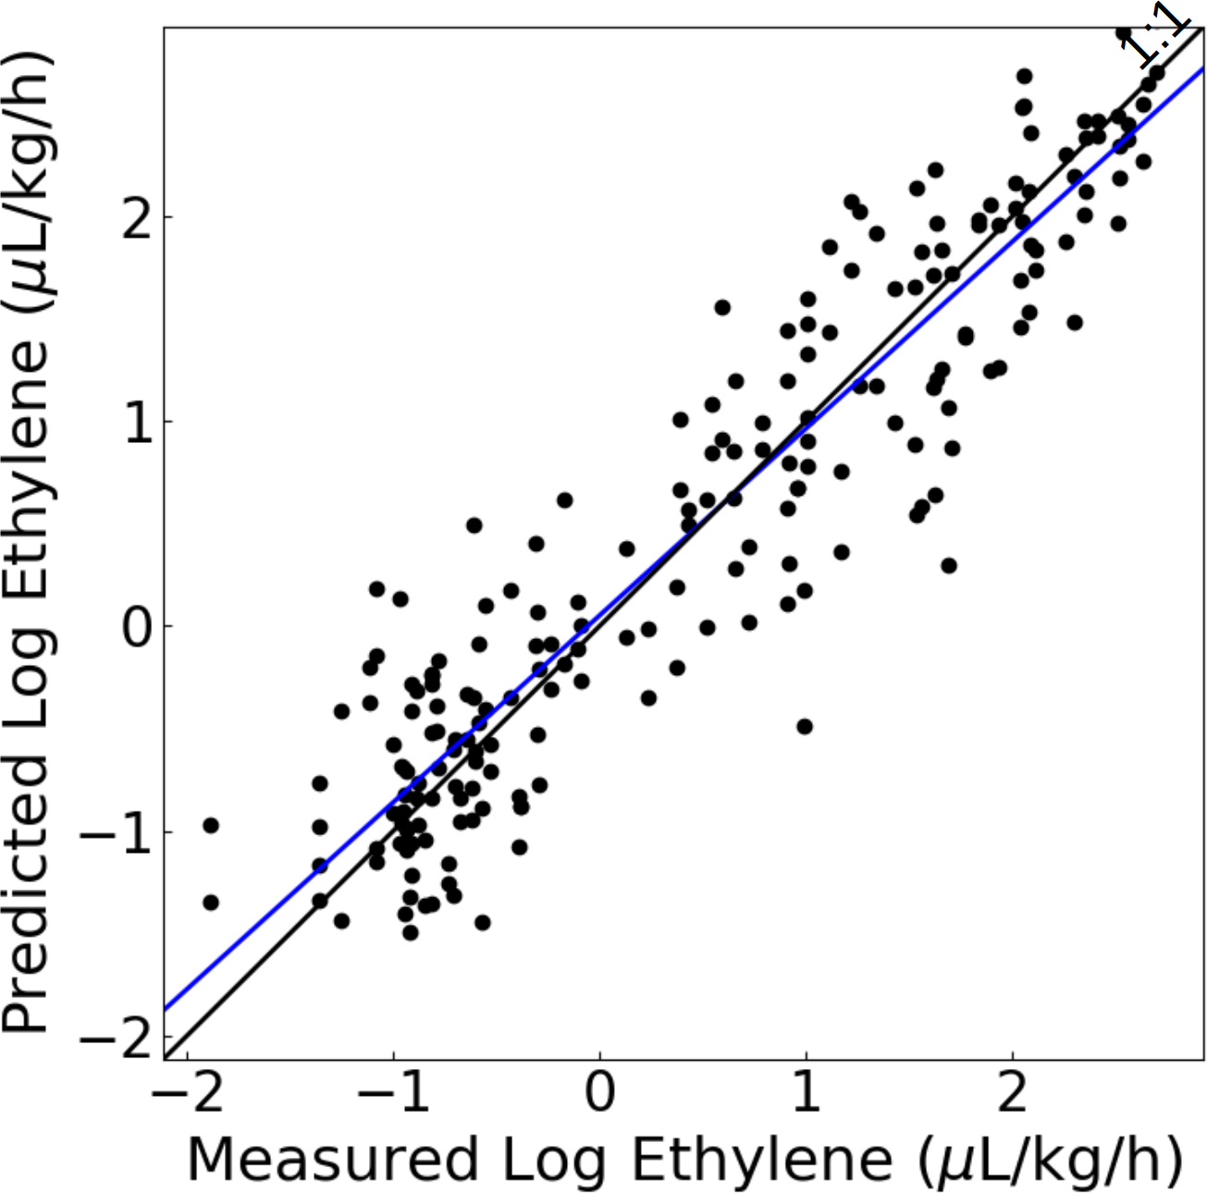
Figure 4. Scatter plots of predicted against observed fruit quality attributes [soluble solids concentration (SSC), flesh firmness (FF), ethylene concentration and index of absorbance difference (I_{AD})] in peach ‘Snow Flame 25’. Blue lines represent cross-validation best linear fits using a partial least square regression (PLS) model. PLS statistics are reported in Table 2.

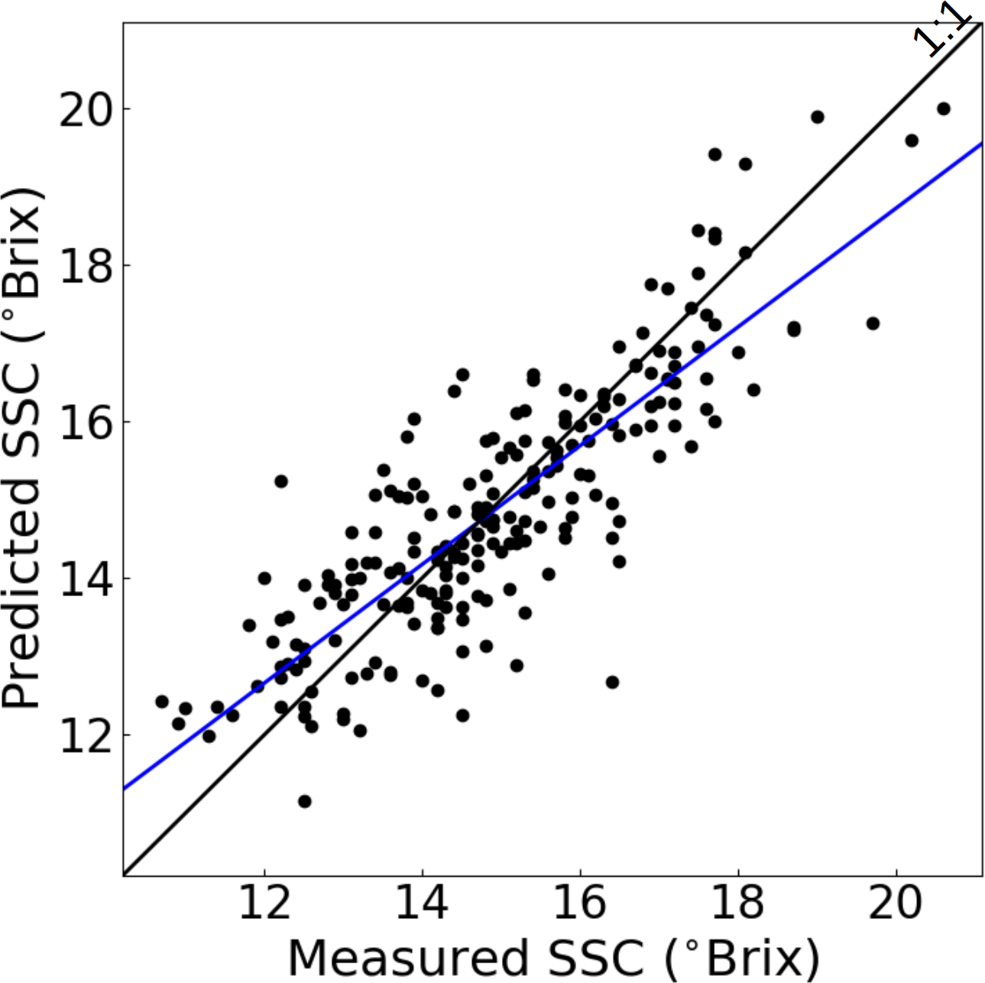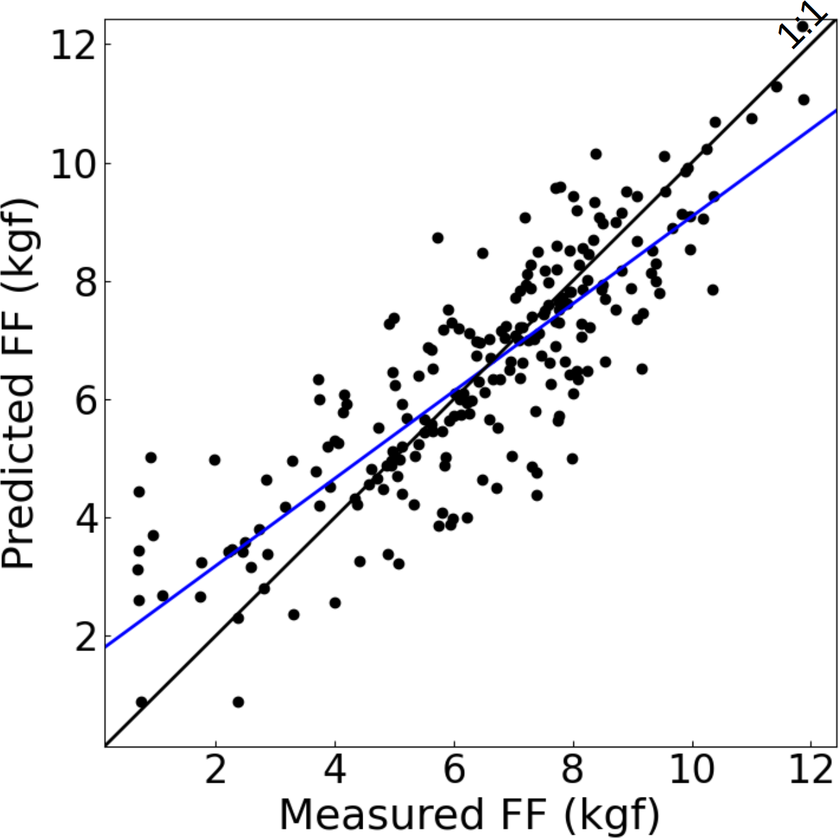
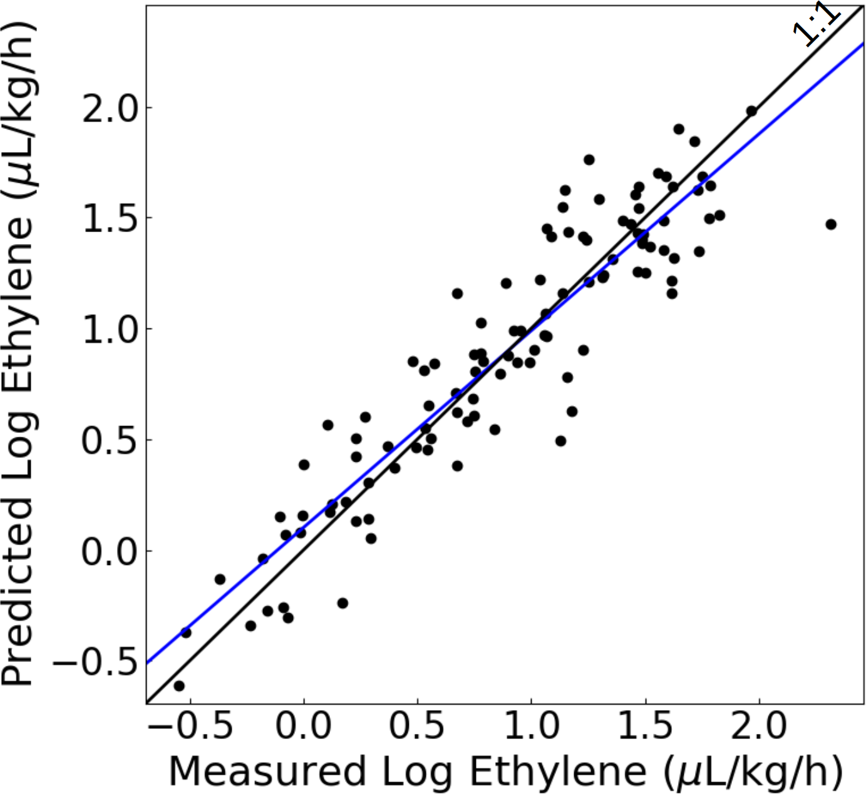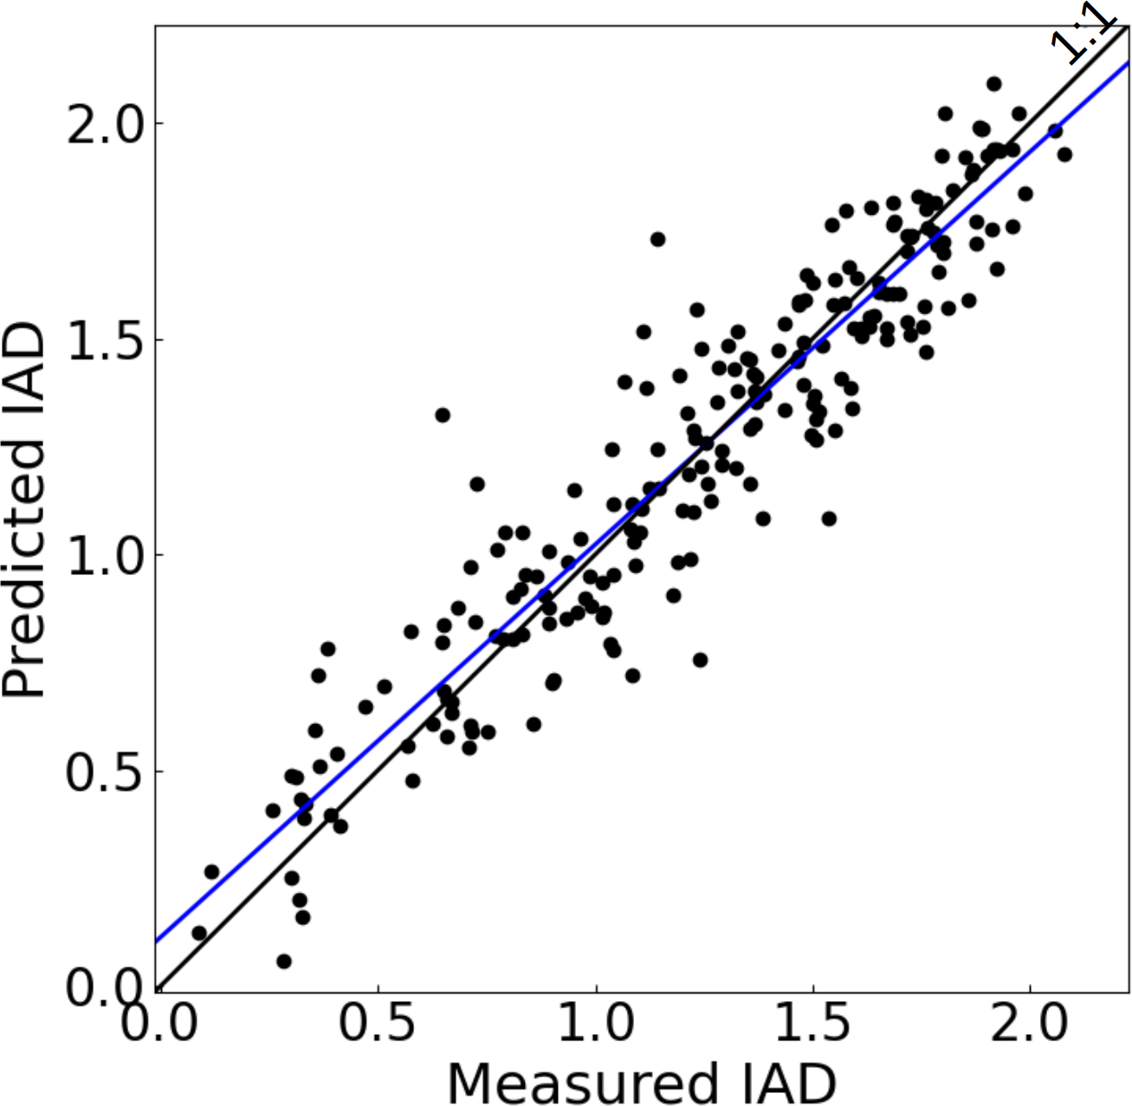
Figure 5. Scatter plots of predicted against observed fruit quality attributes [soluble solids concentration (SSC), flesh firmness (FF), ethylene concentration and index of absorbance difference (I_{AD})] in peach ‘O’Henry’. Blue lines represent cross-validation best linear fits using a partial least square regression (PLS) model. PLS statistics are reported in Table 2.

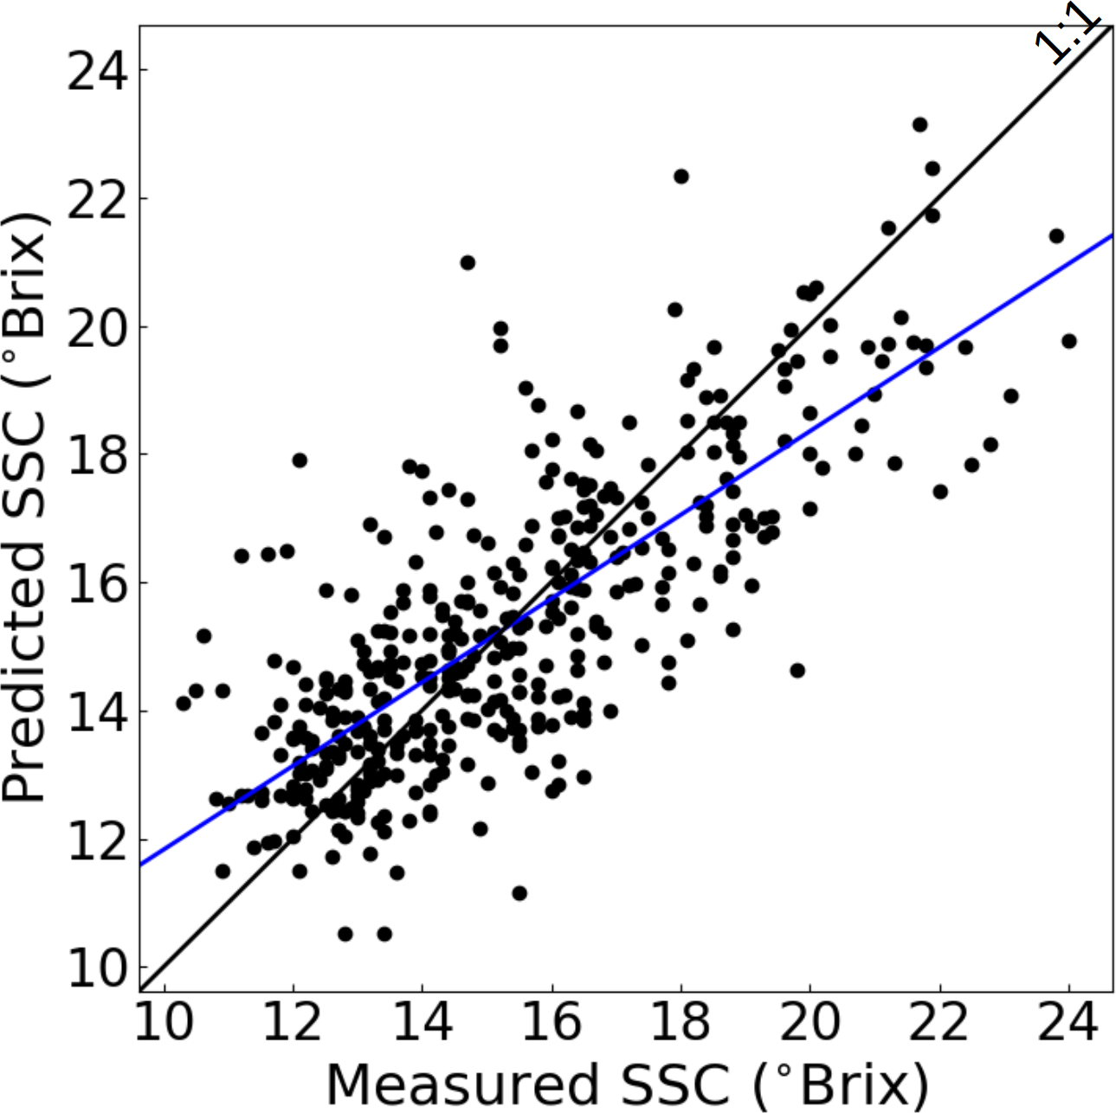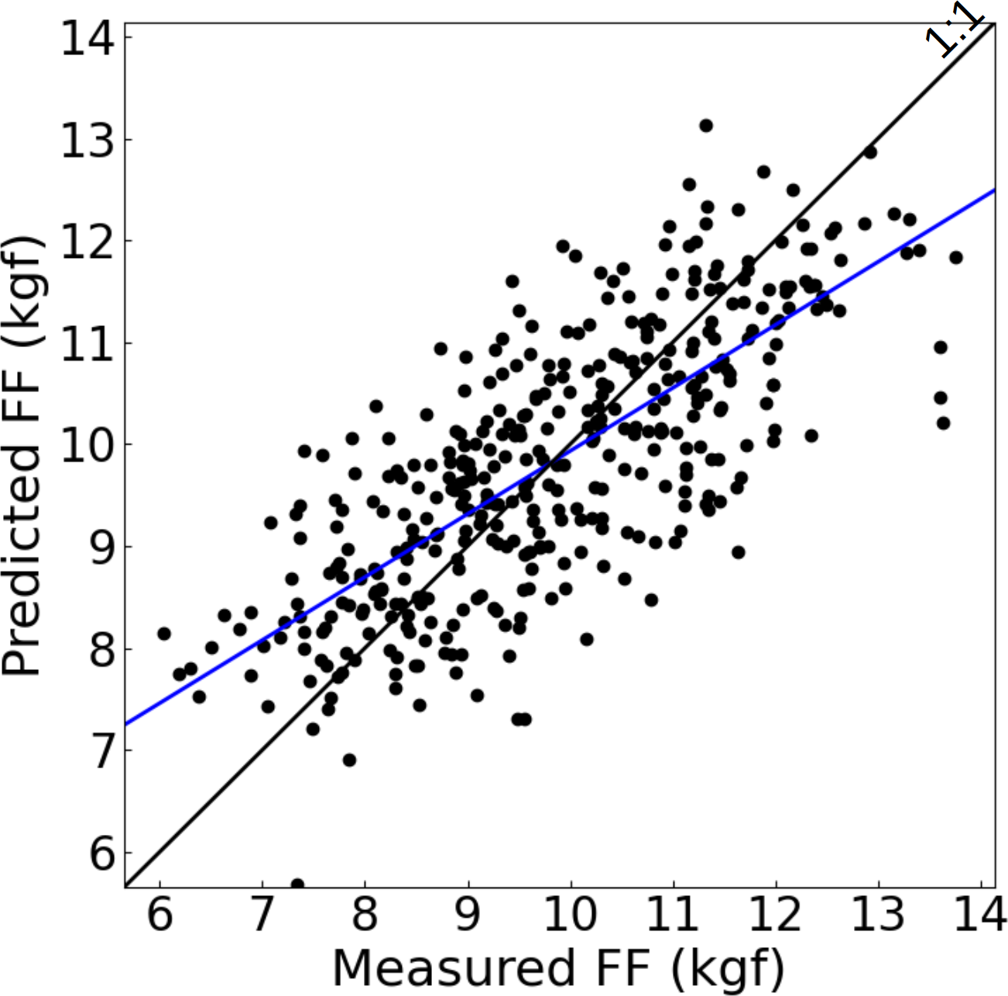
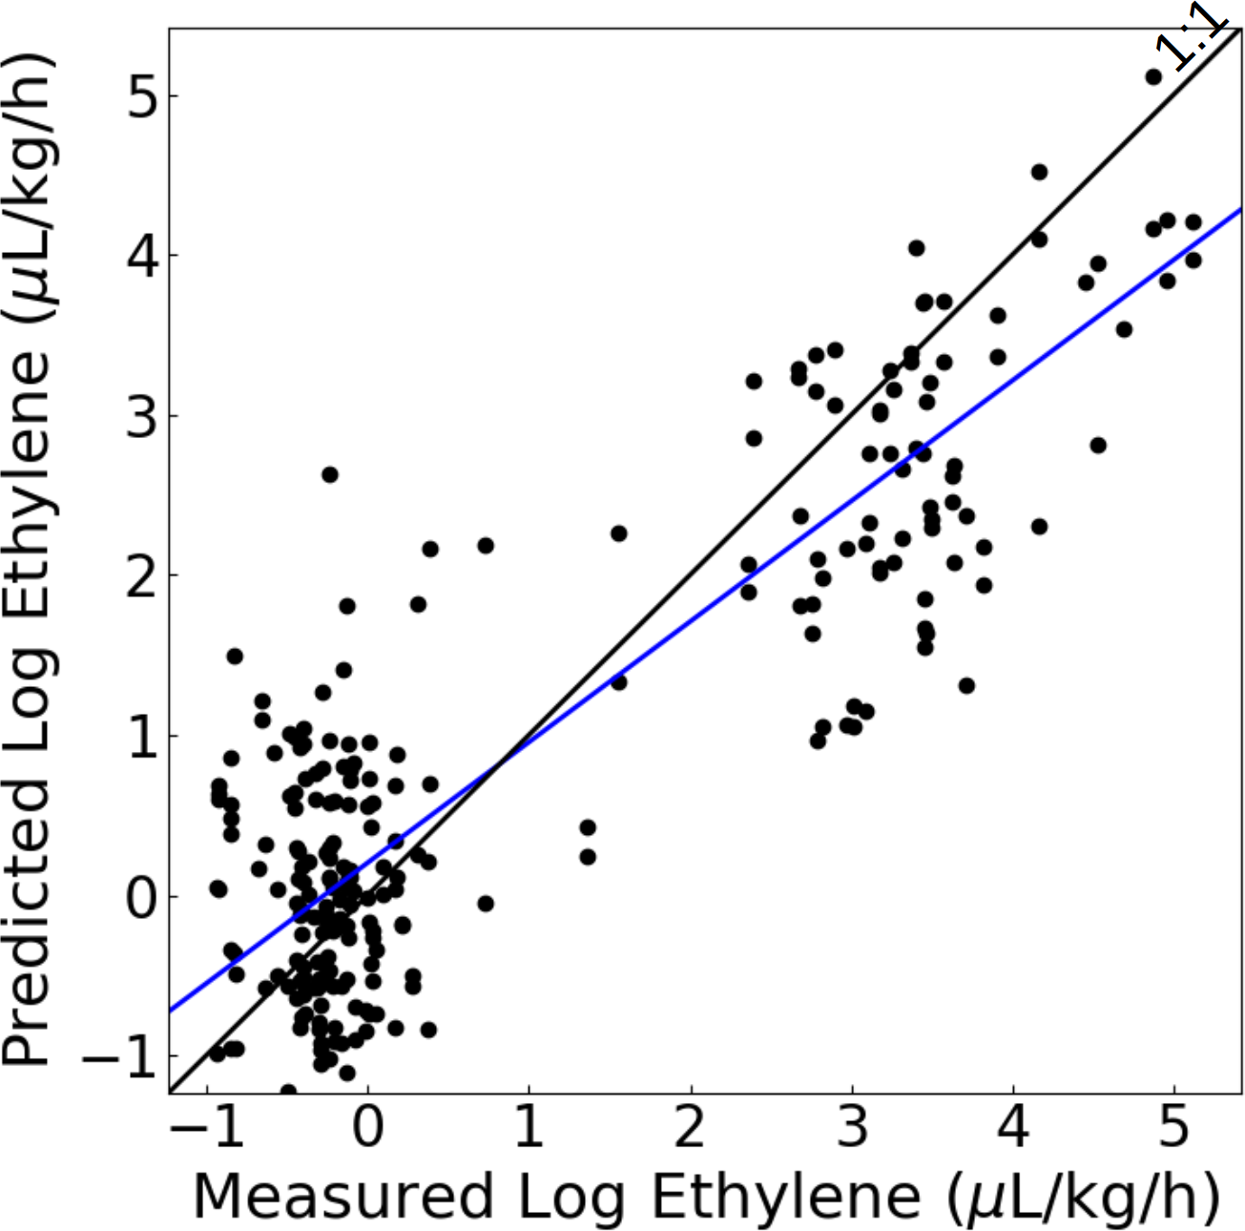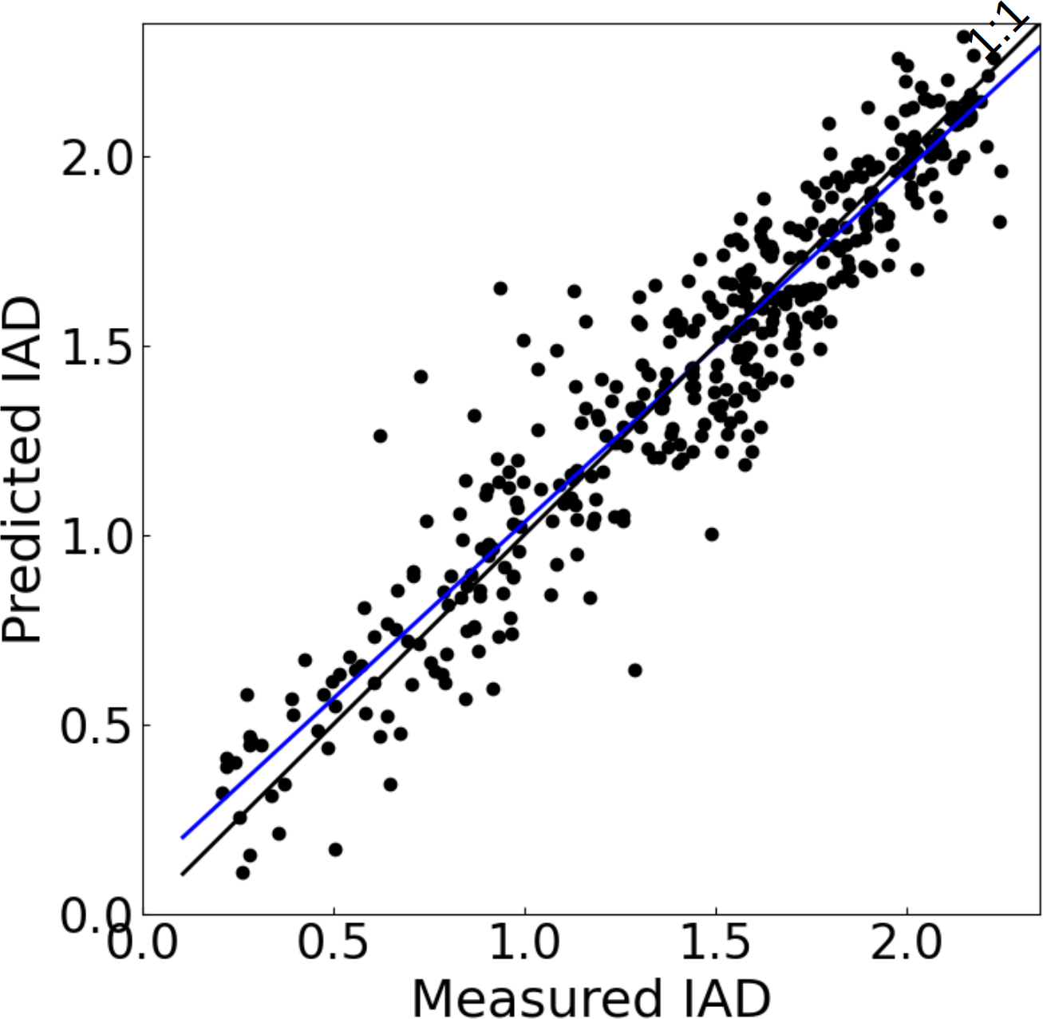
Figure 6. Scatter plots of predicted against observed fruit quality attributes [soluble solids concentration (SSC), flesh firmness (FF), ethylene concentration and index of absorbance difference (I_{AD})] in nectarine ‘Majestic Pearl’. Blue lines represent cross-validation best linear fits using a partial least square regression (PLS) model. PLS statistics are reported in Table 2.

The calculated R2CV, rc, RMSECV, provided valuable information to better assess prediction power and error of the PLS models. A summary of these parameters is presented in Table 2 and highlights differences in models’ robustness between cultivars. AIC values cannot be compared across cultivars and maturity indices, as they are only meant to be used to compare alternative models for the same dataset.
Overall, the fluorescence-reflectance sensor provided robust predictions of fruit quality variables based on rc values — the best parameter to measure instrument’s reliability (i.e. accuracy and repeatability). The PLS models for ethylene, FF, SSC and IAD predictions generated values of rc higher than 0.75. The lowest prediction robustness was observed in SSC, whereas the most reliable predictions were obtained for IAD and Log ethylene, respectively. FF and SSC prediction robustness declined in nectarine ‘Majestic Pearl’, although rc values were still above 0.75 (Table 2).
Table 2. Statistics of the partial least square regression models of the prediction of flesh firmness (FF), soluble solids concentration (SSC), Log ethylene (Log_{ETH}) and index of absorbance difference (I_{AD}) in peach and nectarine cultivars. Spectra used for the models were obtained in a laboratory with a handheld fluorescence-reflectance spectrometer.
Crop and Cultivar | Fruit Quality Attribute | R²_{CV}¹ | r_{c}² | AIC³ | RMSE_{CV}⁴ | LV⁵ | SA⁶
Peach ‘Snow Flame 25’ | FF | 0.90 | 0.95 | 420 | 0.77 | 15 | Vis, IR, UV
 | SSC | 0.64 | 0.81 | 797 | 1.27 | 13 | IR, UV
 | Log_{ETH} | 0.87 | 0.93 | 317 | 0.45 | 10 | UV, IR
 | I_{AD} | 0.91 | 0.96 | -413 | 0.17 | 15 | UV
Peach ‘O’Henry’ | FF | 0.75 | 0.86 | 801 | 1.66 | 13 | Vis, IR, UV
 | SSC | 0.65 | 0.81 | 2578 | 1.08 | 14 | Vis, IR, UV
 | Log_{ETH} | 0.72 | 0.84 | -413 | 0.33 | 14 | IR, UV
 | I_{AD} | 0.86 | 0.93 | -48 | 0.18 | 12 | UV
Nectarine ‘Majestic Pearl’ | FF | 0.61 | 0.78 | 150 | 0.97 | 10 | Vis, IR, UV
 | SSC | 0.60 | 0.76 | 606 | 1.73 | 14 | Vis, IR, UV
 | Log_{ETH} | 0.77 | 0.87 | 734 | 1.37 | 15 | Vis, IR, UV
 | I_{AD} | 0.92 | 0.96 | -1405 | 0.15 | 12 | Vis, IR, UV
¹Coefficient of determination of the cross-validation, ²Lin’s concordance correlation coefficient, ³Akaike information criterion, ⁴root mean square error of the cross-validation and ⁵number of latent variables, ⁶simulated annealing spectra.

Field testing of the handheld fluorescence-reflectance sensor
Figure 7 shows predicted plotted against the observed fruit FF and SSC obtained in the field using ‘September Sun’ peach. The models of fruit quality attributes obtained in the field using ‘September Sun’ peach are shown in Table 3. Here, the PLS model for FF and SSC predictions generated the R²_{CV} and r_{c} statistics of 0.70 – 0.75 and 0.84 – 0.86, respectively. These values indicate that the calibration models were sufficient to provide reliable estimates of fruit quality. FF prediction accuracy (r_{c} = 0.86) in ‘September Sun’ (Table 3) was identical to the one observed in the other yellow-flesh peach used in this study (i.e. ‘O’Henry’, Table 2), despite the models for the former being done in laboratory conditions and the models for the latter being done in situ. Prediction accuracy of SSC was similar in the two yellow fleshed cultivars (r_{c} in ‘O’Henry’ = 0.81; r_{c} in ‘September Sun’ = 0.84).

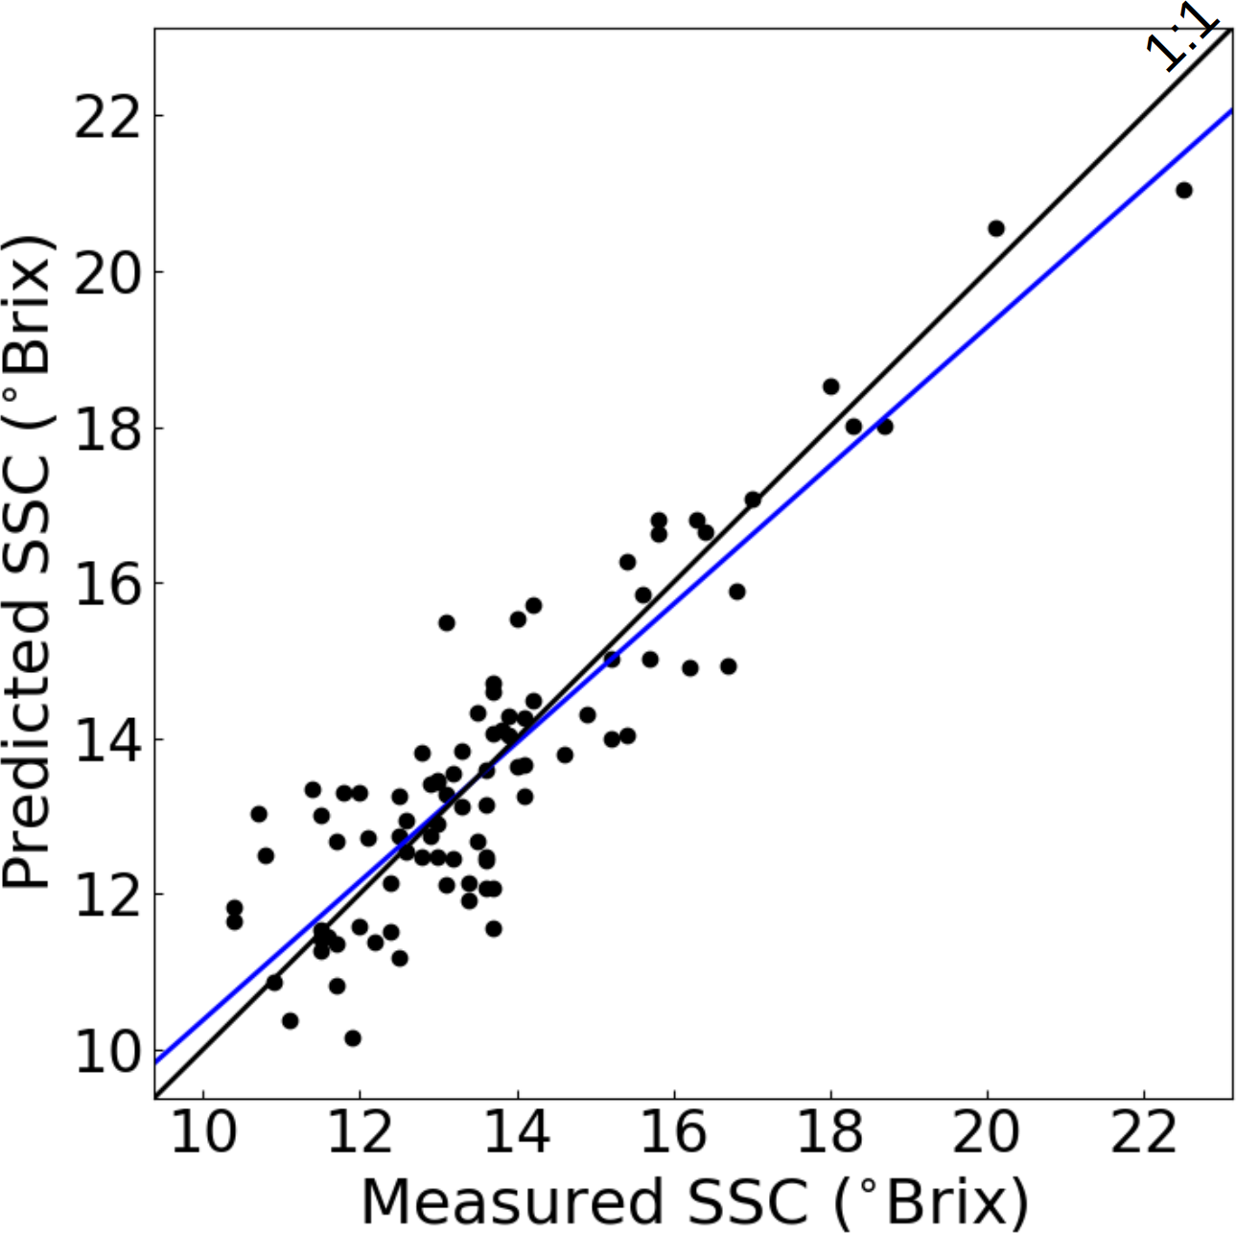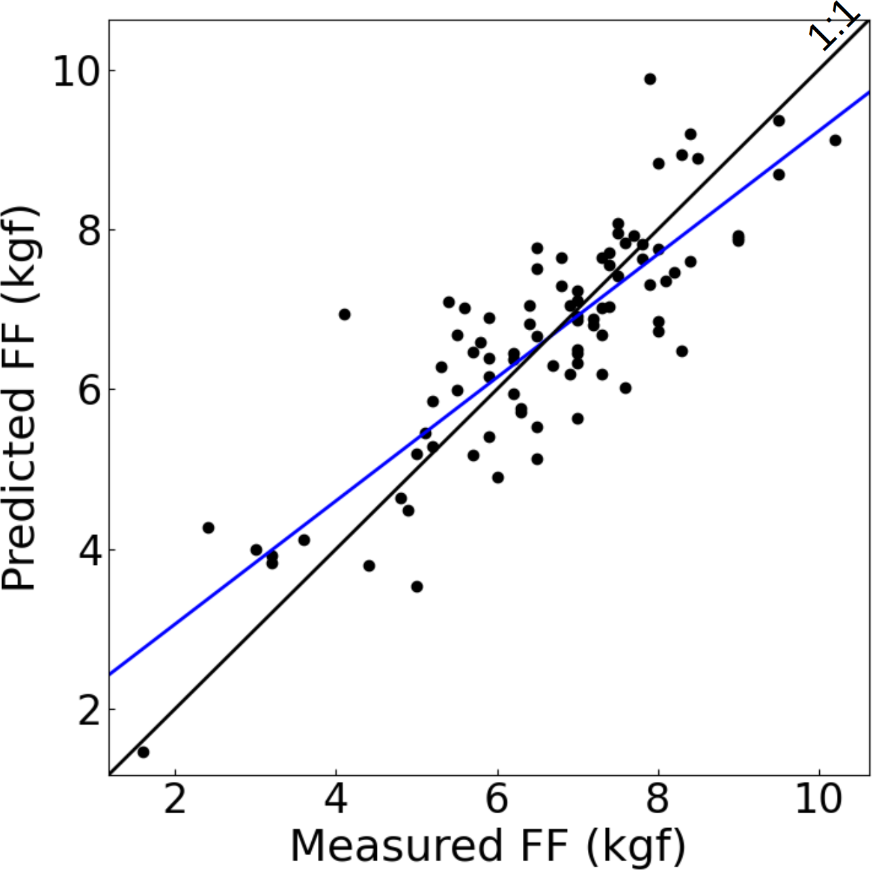
Figure 7. Scatter plots of predicted against observed fruit quality attributes [soluble solids concentration (SSC) and flesh firmness (FF)] in peach ‘September Sun’. Blue lines represent cross-validation best linear fits using a partial least square regression (PLS) model. PLS statistics are reported in Table 3.

Table 3. Statistics of the partial least square regression models of the prediction of flesh firmness (FF) and soluble solids concentration (SSC) in ‘September Sun’ peach. Spectra used for the models were obtained in the field (i.e. in situ) with a handheld fluorescence-reflectance spectrometer.
Crop and Cultivar | Fruit Quality Attribute | R²_{CV}¹ | r_{c}² | AIC³ | RMSE_{CV}⁴ | LV⁵ | SA⁶
Peach ‘September Sun’ | FF | 0.75 | 0.86 | 3 | 0.79 | 13 | IR, UV
 | SSC | 0.70 | 0.84 | 681 | 1.17 | 14 | IR, UV
¹Coefficient of determination of the cross-validation, ²Lin’s concordance correlation coefficient, ³Akaike information criterion, ⁴root mean square error of the cross-validation and ⁵number of latent variables, ⁶simulated annealing spectra.

DISCUSSION
This study investigated the accuracy and utility of a prototype handheld fluorescence-reflectance spectrometer for application in the field (orchard) and export chain (post-harvest) measures of stone fruit quality. The sensor affords an objective (data-driven), non-destructive and rapid assessment of the key factors of fruit quality: FF, SSC, and ethylene emission.
For the Summerfruit industry, optimal fruit quality, particularly maturity, has the potential to increase the competitiveness and drive growth in export markets. Poor orchard decisions that reduce fruit quality can have a major impact on business profitability. Most businesses are reliant upon subjective orchard inspection of fruit quality and post-harvest grading and sorting for their decision making. Potential benefits to the stone fruit industry growers and packhouses of this new AgTech include:
- Pre-harvest orchard management tactics
- Earlier and smarter data-driven business decisions around product market destination and promotion
- Harvest timing
- Labour savings by reducing time it takes to test fruit quality
- Improved sustainability by reducing waste in the supply chain
Further work on assessing the utility and refining the sensor with key stakeholders (growers, packhouses) is planned as part of this project. This ‘road testing’ phase of the work forms an important stage for the evaluation of sensors and platforms that are capable of cost-effectively predicting yield, harvest timing and fruit quality in the supply chain for the Summerfruit industry.
Additional sensor calibration and validation of crops (e.g. plums and apricots) and cultivars will make the sensor more applicable to the stone fruit industry. Improvements in the usability, design, data flow and display features of the smartphone APP will be adopted following feedback from users in forthcoming growing seasons.
Commercialisation of the sensor will increase the exposure and adoption by the Summerfruit industry as the sector works towards modernising traceability systems for a digital future. Further information about the sensor is available online: https://rubenstech.com. Appendix 1 presents the product flyer for the handheld spectral sensor.

CONCLUSION
The handheld fluorescence-reflectance sensor used in this study offers rapid, in situ, non-destructive, improved sample size, smartphone connectivity, and cloud-based workflow and data capture measurements of fruit quality for Summerfruit growers and packhouses. The sensor proved easy to use, accurate and robust for measures of peach and nectarine fruit quality: FF, SSC and ethylene emission. The instrument can be used for fruit quality data collection and analytics in situ or post-harvest as it is interfaced via Bluetooth connectivity with a smartphone application that serves as data logger and stores data in the internal memory. The use of an external data logging device such as a smartphone or a tablet contributes to the reduction of the instrument’s size and weight, making it a practical and portable tool for Summerfruit industry applications (i.e. orchard, packhouse, cool store, distribution centre).

RECOMMENDATIONS
The adoption of quantitative measures of ethylene status, FF and SSC for fruit quality determination helps overcome qualitative and subjective classification into ‘ripeness’ categories and opens the door to powerful machine learning algorithms that can quickly monitor fruit maturity changes prior to harvest. For the Summerfruit industry, the handheld fluorescence-reflectance sensor offers the sector a data driven AgTech tool to modernise traceability of fruit quality for a digital future. For example, algorithms for the detection of fruit quality have a great potential for precision agriculture applications involving AgTech such as robots, drones, mobile platforms and robotic harvesting for automation of common ‘labour intensive’ orchard practices like fruit maturity estimation and crop harvesting.

REFERENCES
Akaike, H. (1974). A new look at the statistical model identification. IEEE Trans. Automat. Contr. 19, 716–723.
Crisosto, C. H. (1994). Stone fruit maturity indices: a descriptive. Postharvest News and Information, 5(6), 65N–68N.
Frisina, C., Stefanelli, D. Giri, K., Tomkins, B. (2018). A revised method for the field collection and storage of fruit ethylene samples using evacuated vials. Scientia Horticulturae 236, 123–126.
IHS Global TRADE ATLAS. Fresh Intelligence analysis Accessed July 2019. http://www.gtis.com/gta
Lin, L.I.-K. (1989). A concordance correlation coefficient to evaluate reproducibility. Biometrics, 45, 255–268.
O’Connell, M.G. (2020). Crop load and canopy architecture affect yield and fruit quality of 'Golden May' apricot. Acta Horticulturae (submitted).
O’Connell, M.G., Scalisi, A. (2021). Sensing fruit and tree performance under deficit irrigation in ‘September Bright’ nectarine. Acta Horticulturae 1314, 9–16.
O'Connell, M.G., Stefanelli, D. (2020a). Effect of crop load management and canopy architecture on yield and fruit quality of late-season plum 'Angeleno'. Acta Horticulturae 1281, 227–234.
O'Connell, M.G, Stefanelli, D. (2020b). Effects of rootstock and crop load management on yield and fruit quality of early-season nectarine 'Rose Bright' and late-season peach 'September Sun'. Acta Horticulturae 1281, 121–130.
Pedregosa, F., Varoquaux, G., Gramfort, A., Michel, V., Thirion, B., Grisel, O., Blondel, M., Prettenhofer, P., Weiss, R., Dubourg, V. and Vanderplas, J., 2011. Scikit-learn: Machine learning in Python. the Journal of machine Learning research, 12, pp.2825-2830.
Pelliccia, D. (2021). Wavelength Band Selection with Simulated Annealing. Available online: https://github.com/nevernervous78/nirpyresearch/blob/master/snippets/Wavelength%20band%20selection%20with%20simulated%20annealing.ipynb (accessed on 22 June 2021).
Scalisi, A., O’Connell, M.G., Bianco, RL. (2021). Field non-destructive determination of nectarine quality under deficit irrigation. Acta Horticulturae 1314, 91–98.
van Laarhoven, P.J.M.; Aarts, E.H.L. (1987). Simulated annealing. In Simulated Annealing: Theory and Applications. pp. 7–15. (Springer: Dordrecht, The Netherlands).

Acknowledgements
The technical support and assistance of Dave Haberfield, Cameron O’Connell and Laura Phillips is gratefully acknowledged. This study was financially supported by the project ‘Deploying real-time sensors to meet Summerfruit export requirements’ funded by Food Agility CRC Ltd., under the Commonwealth Government CRC Program with co-investment from Agriculture Victoria and Summerfruit Australia Limited. The CRC Program supports industry-led collaborations between industry, researchers and the community.

Appendices
Appendix 1. Handheld fluorescence-reflectance sensor (Rubens Technologies Pty Ltd) flyer.

