Smart sensing technologies for Precision Crop Load Management in Australian Summerfruit Orchards
Smart sensing technologies are currently being evaluated (Project SF23000 - Precision Summerfruit Orchards) in measuring fruit and tree parameters. The primary objective of this assessment is to determine technologies that enhance outturn, production and labour efficiency.

The level of uniformity in tree size, fruit number, fruit diameter and fruit colour is being investigated within blocks of commercial Summerfruit crops (peach, nectarine, apricot and plum) in key growing regions (Sunraysia, Murray Valley, Goulburn Valley) of Australia. Pre-harvest and harvest scans of orchards using precision sensing technologies, enable real-time data collection on production uniformity, canopy characteristics, and provide agronomic insights for improved orchard management.

A survey was conducted on state-of-the-art commercially available smart technologies that use contact, proximal and remote approaches to measure canopy metrics and fruit and flower parameters.

The sensing technology being evaluated in project SF23000 includes mobile ground-based Cartographer (Green Atlas), drone (Outfield Technologies Orchard Management Platform) and smartphone APPs (Aerobotics, Hectre, Croptracker, DataLogger paired with Bluetooth digital calipers).

Technology comparisons and assessments
The following tables show sensing technology for fruit and tree parameters in relation to detection and data capture for flowers, fruit number, fruit size, fruit colour, tree size and yield forecasting. The tables have been grouped into three categories: handheld, proximal and remote sensing. Each table provides a list products and their sensor type, what they measure, sample size, and an overall rating – a precision agriculture score.
Technologies were evaluated according to:
- Data type captured
- Sample size
- Accuracy and resolution
- Cost
- Skill requirements
- Data integration
- Compatibility with existing farm management decision support software
- Tech support

Table 1. Handheld sensors that make direct physical contact with fruit or tree.
Sensor | Scale | Sample size | Parameter | Precision Agriculture score  (1–10) | Product
Bluetooth calliper | Fruit, Tree | Small | Fruit size, Trunk size | 3 | iGaging OriginCal  Syntek  Maxigear  Mitutoyo U-Wave
Bluetooth colourimeter | Fruit | Small | Fruit colour | 5 | Rubens Technologies
Bluetooth spectrometer | Fruit | Small | Fruit maturity  Fruit sweetness | 5 | Rubens Technologies

Table 2. Proximal sensors that sense fruit or tree information in close range.
Sensor | Scale | Sample size | Parameter | Precision Agriculture score  (1–10) |  | Product
Handheld
Smartphone | Fruit, Tree | Medium | Fruit number, Fruit size, Fruit colour, Tree size, Yield forecast | 5 – 7 | Aerobotics  Croptracker  Hectre  Agerpoint  Petiole ProTM  FruitScout  SoYield  PixFruit
Terrestrial (e.g., ATV, tractor)
Camera, LiDAR | Blossom, Fruit, Tree | High | Blossom load, Fruit number, Fruit size, Fruit colour, Tree size | 6 – 10 | Green Atlas Cartographer  Revolute Systems RevScout  Fruitometry  Intelligent Fruit Vision  Aurea TreeScout  Vivid machines  Orion FruitMaps  Bitwise GreenView  FruitCast

Table 3. Remote sensors that sense fruit or tree information at a distance.
Sensor | Scale | Sample size | Parameter | Precision Agriculture score  (1–10) |  | Product
Drone, aircraft
Camera | Fruit, Tree | High | Fruit number, Fruit size, Tree size | 5 – 8 | Outfield Technologies  Sentera  Aerobotics
Satellite
Camera | Tree | High | Tree size | 5 | Ceres Imaging
Multispectral camera | Field | High | Yield forecast | 3 | Australian Tree Crop Map
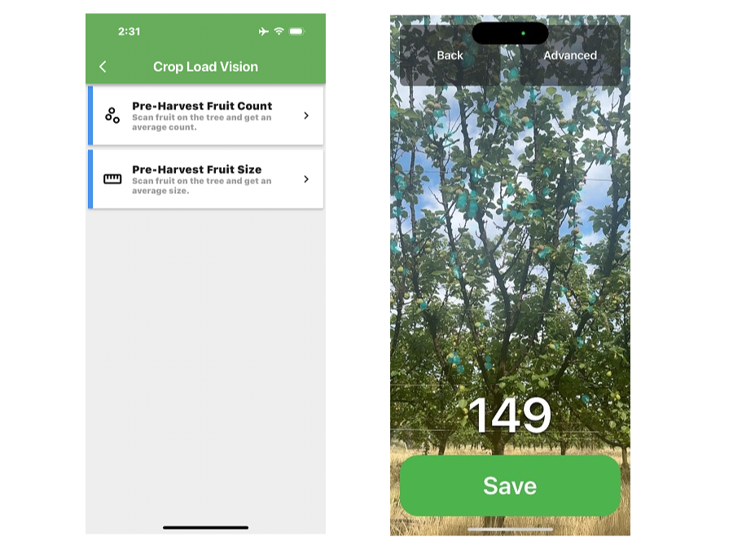
Image 1: Crop tracker smartphone APP for fruit count and fruit size

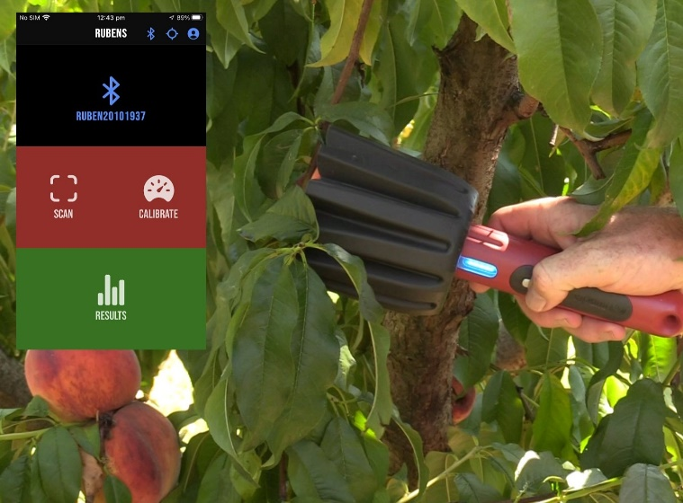

Image 2: Rubens Sensor and smartphone APP for measuring fruit sweetness, firmness and maturity
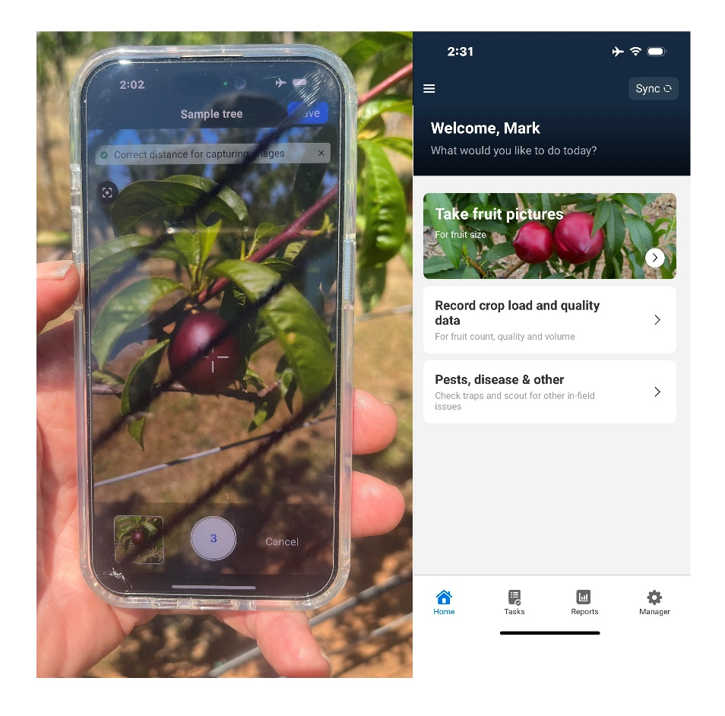
Image 3: Aerobotics smartphone APP for fruit size

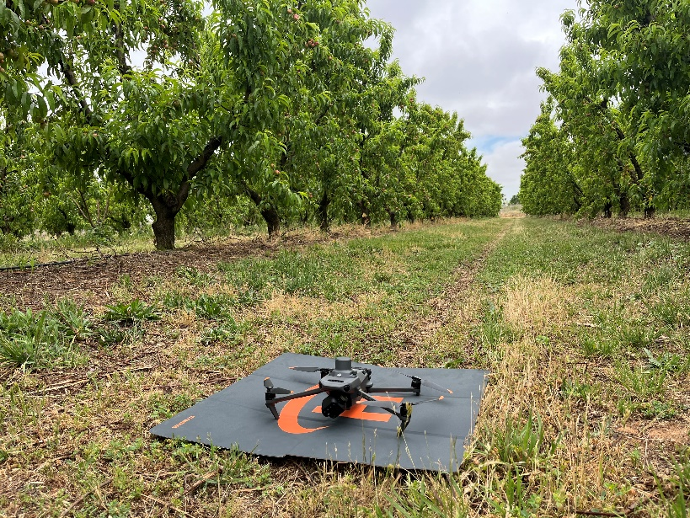
Image 4: Outfield Technologies platform utilising drone for aerial sensing of tree size and fruit number

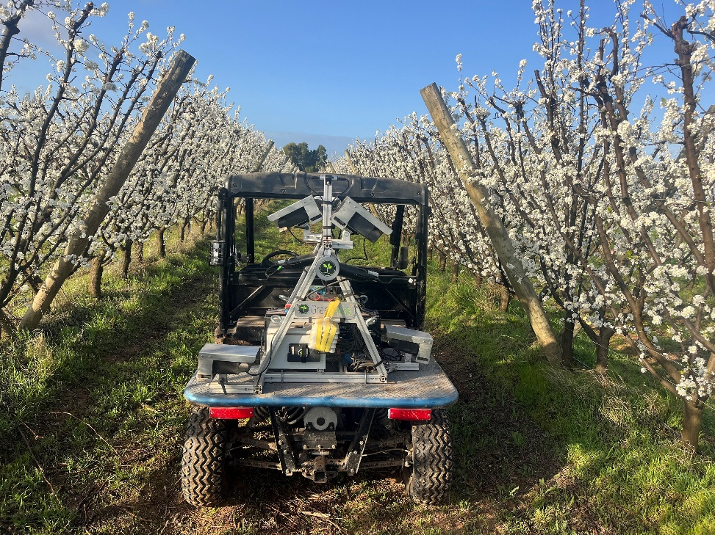

Image 5: Green Atlas Cartographer using sensors to scan blossom load

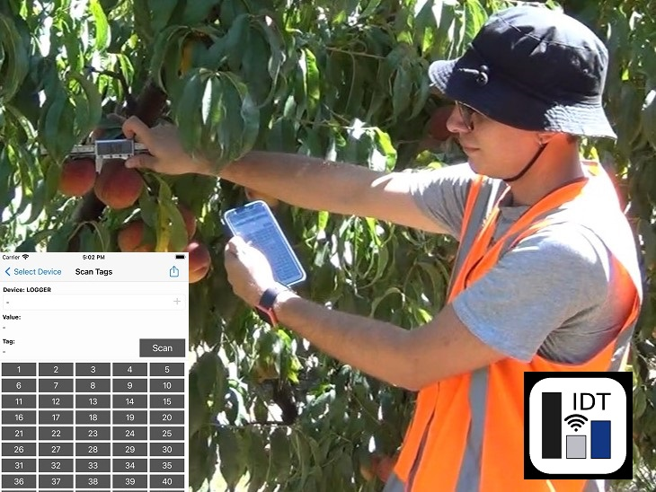
Image 6: Digital Bluetooth callipers with DataLogger smartphone APP for fruit size

Further information
Mark O’Connell, Agriculture Victoria mark.oconnell@agriculture.vic.gov.au

Acknowledgments
This project Precision summerfruit orchards (SF23000) has been funded by Hort Innovation, using the Summerfruit research and development levy, contributions from the Australian Government and co-investment from Agriculture Victoria. Hort Innovation is the grower-owned, not-for-profit research and development corporation for Australian horticulture.

These publications may be of assistance to you but the State of Victoria and its officers do not guarantee that these publications are without flaw of any kind or is wholly appropriate for your particular purposes and therefore disclaims all liability for any error, loss or other consequence which may arise from you relying on any information in these publications.

