FACT SHEET

Tree survival signatures for horticulture industry resilience to drought

Building drought resilience in orchards.
The Tree survival signatures for horticulture industry resilience to drought project is a $7.8 million, five-year initiative developing practical tools and guidelines to help orchardists make more informed irrigation decisions during drought and improve long-term orchard resilience.

Researchers are identifying critical water stress thresholds in almond, pear and nectarine trees before long-term productivity is impacted. By establishing ‘survival signatures’ — a response function that describes the relationship between water status and subsequent season productivity in fruit and nut tree crops — the project will deliver practical irrigation decision-support tools and management guidelines to help growers:

- Better prioritise water resources during drought
- Be aware and make more informed irrigation decisions
- Protect orchard long-term health and productivity
- Improve tree recovery following drought
- Build long-term orchard resilience.

Turning research into practical solutions.
Over four growing seasons, the project combines advanced aerial hyperspectral and thermal remote sensing, in-situ sensors, robust field trials, on-farm demonstrations and industry collaboration to better understand how orchard trees respond to drought.

By integrating cutting-edge technology with grower knowledge and on-ground research, the project will generate the evidence needed to develop practical irrigation decision-support tools that are relevant, accessible and ready for on-farm adoption.

Meeting the challenge of drought.
Australia's $18.4 billion horticulture industry faces increasing pressure from climate variability and increased droughts, making it harder for growers to balance limited water supplies with long-term orchard productivity. During the Millennium Drought (1996–2010), Victoria's annual catchment streamflow declined by 20–40%, reducing water allocations and forcing many orchardists to make difficult irrigation decisions.

By improving our understanding of how trees respond to water stress, this project will provide Victorian growers with practical evidence-based guidance to protect orchard productivity, maximise tree survival and support faster recovery after drought.

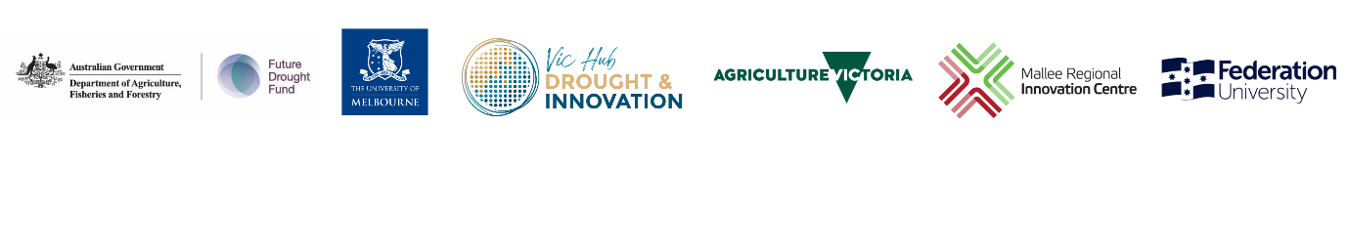
The Tree survival signatures for horticulture industry resilience to drought project is part of the Australian Government’s national Long-term Trials of Drought Resilient Farming Practices Program, funded through the Future Drought Fund.

Learn more at www.hin.com.au.

